CS 437 Lab 1: IoT Devices

John Wennerstrum

Net Id: wenners2

Demo Video: https://uofi.box.com/s/7sf9wih8oagcr6r6fj60lhd771496j17

Code Repository: https://github.com/jwennerstrum1/iot_lab1

# Part 1

## PiCar Assembly

In the first part of the lab, the PiCar kit was assembled using the SunFounder user manual [1]. Pictures of the fully assembled car are presented below:

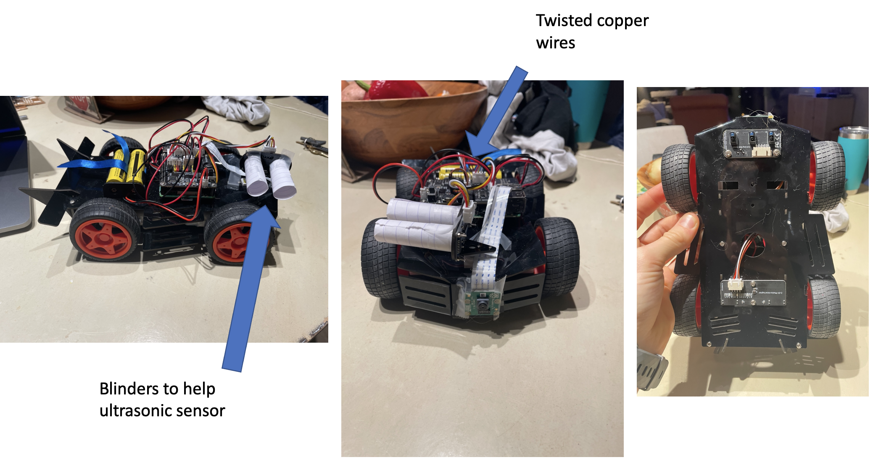

**Figure 1: Pictures of the fully assembled PiCar**

Distinguishable features of the car include blinders and twisted wires connecting the ultrasonic sensor and the PiCar HAT module. Both modifications serve the purpose of improving the accuracy of the readings from the ultrasonic sensor—the blinders preventing interference from peripheral objects and the twisted wires minimizing noise due to electromagnetic interference [2].

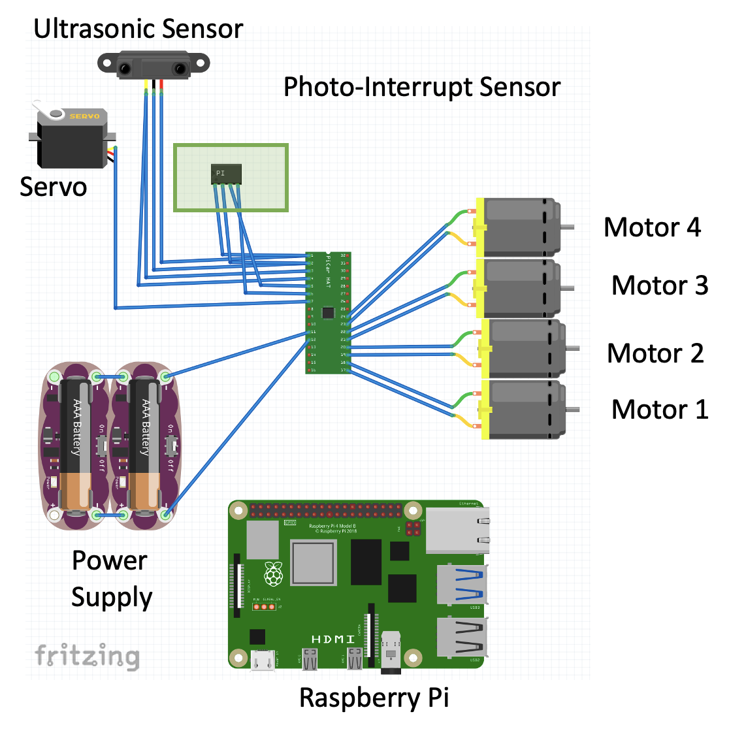

**Figure 2: A wiring schematice of the PiCar**

The crude schematic of the PiCar HAT wiring is diagramed in Figure 2. For simplicity’s sake, Figure 2 does not show the connection between the SunFounder HAT module and the Raspberry Pi. As a “Hardware Attached on Top” (HAT) module, it is designed to sit directly on top of the row of GPIO pins protruding from the pi. Moreover, the HAT module is shown as a “black-box” component, and the icon does not match the physical appearance of the board in real life. In the diagram, the photo interrupt sensor and the ultrasonic sensor’s shared connections to the ground (GND) and power supply (3v3) pins are for schematic representation only. The physical PiCar HAT board has separate connections for these lines which the peripheral components are individually connected to. To help the reader understand which connections correspond to which pins on the HAT module, a “black-box” pinout diagram is shown in figure 3 that matches the pin positioning in the breadboard view in figure 2.

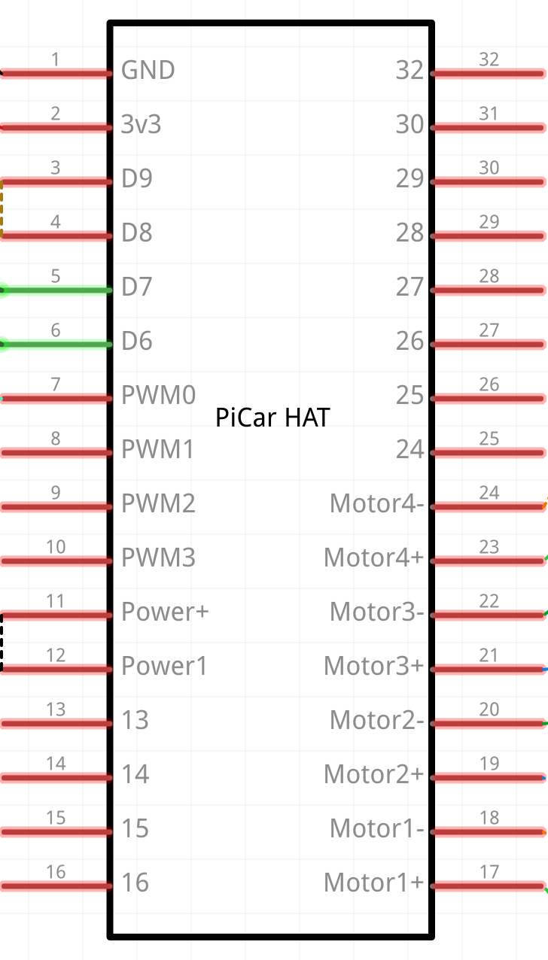

**Figure 3: Pinout schematic of the Sunfounder PiCar HAT module**

After assembling the car, executing “fc.forward(<power>)” command from the Picar-4wd GitHub library unfortunately caused the car to navigate backwards [3]. Rather than rewiring the car to reverse this behavior, I wrote wrapper functions in my navigation module that handle this for me:

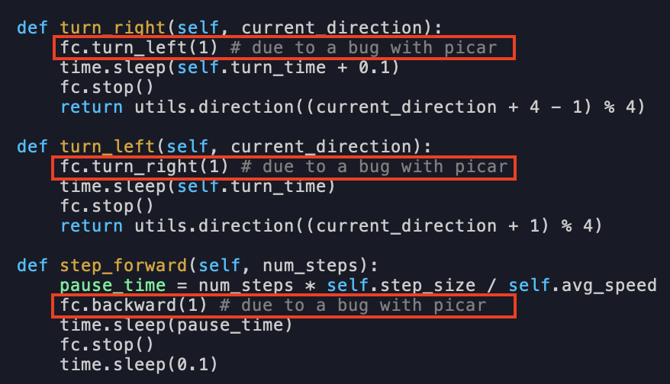

**Figure 4: Wrapper methods to move the car forwards, right, and left**

## PiCar Library Exploration

While exploring the PiCar-4wd library, I leveraged pre-built examples to verify functionality of each hardware component connected to the Raspberry Pi. Executing “picar-4wd web-example” from terminal, for example, spun up a web application that provided an interface to scan the environment with the ultrasonic sensor, power all four motors on the car, and measure the speed of the car.

Sample code from the Lab 1 material was also utilized to print speed readings to terminal and relate the input power to the resulting speed values in millimeters per second. A snippet of this code is shown below:

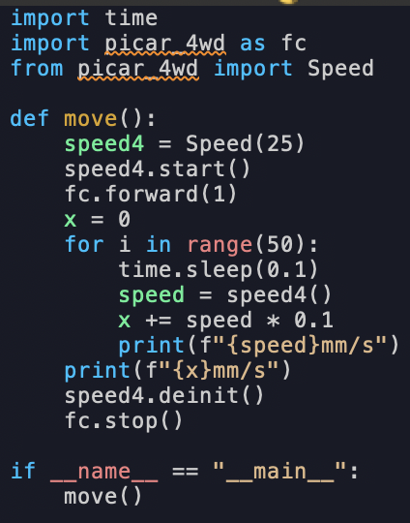

**Figure 5: Powering the car with a constant PWM frequency and printing speed readings from the photo-interrupt sensor to terminal [4]**

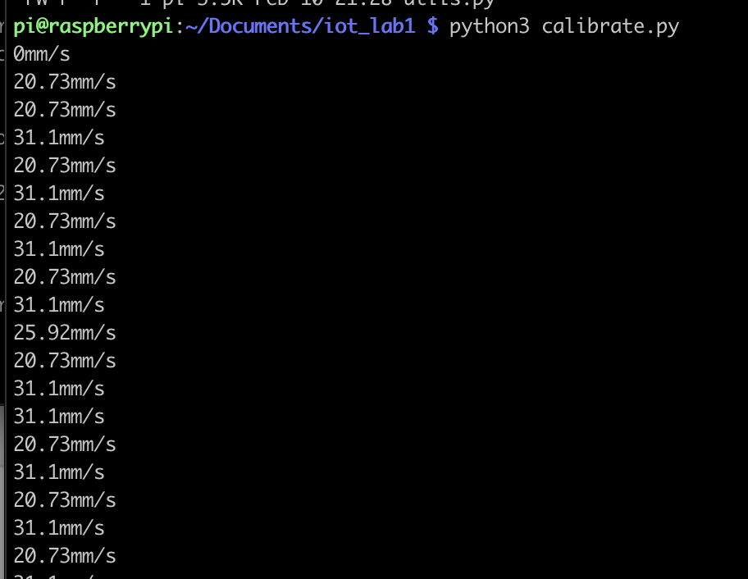

**Figure 6: Speed readings from the photo-interrupt sensor when supplying a power value of 1**

The printout after executing the program in Figure 5 with a power value of 1 supplied to the “fc.forward” command is shown in Figure 6. In later portions of the lab, this and a similar script which turned the car at a constant speed were used to calibrate constant parameters in a navigation module responsible for accurately moving the car. After executing these scripts several times, I determined that with a power value of 1 driving the motors, the car would navigate 25 mm/sec and take roughly 1.3 seconds to turn +/-90°. These values were used as default values in the navigation module, shown in Figure 7.

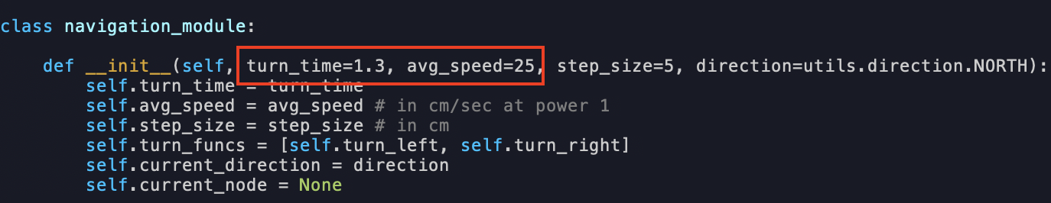

**Figure 7: The car’s navigation module uses constant parameter to perform accurate translational and rotational movements**

The turn time and average speed parameters were used in wrapper methods to move the car forward a specific number of steps and rotate the car left and/or right by exactly 90 degrees, shown in Figure 8.

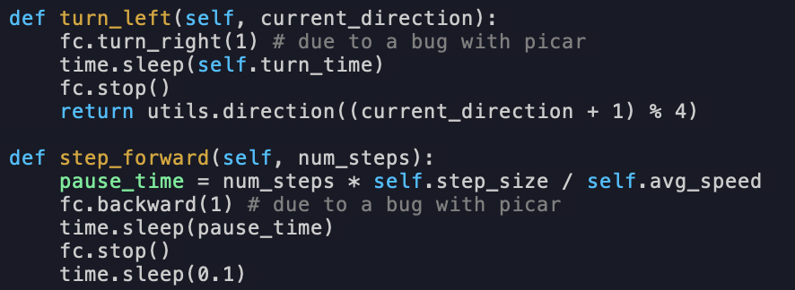

**Figure 8: The car’s average speed was used to step calculate the time taken to drive the car specified distances**

## Scanning & Driving

The python script “obstacle-avoidance.py” from the picar-4wd GitHub repository integrated the ultrasonic sensor readings with car’s motor control [3]. The resulting navigation scheme moves the car forward until an object is detected less than 2 cm from the front of the car. At this point, the car will pivot to the right, continue moving forward, and repeat this cycle. This script, shown below, was used in step 4 of the first part of the lab to navigate the car around walls, chairs, and other barriers.

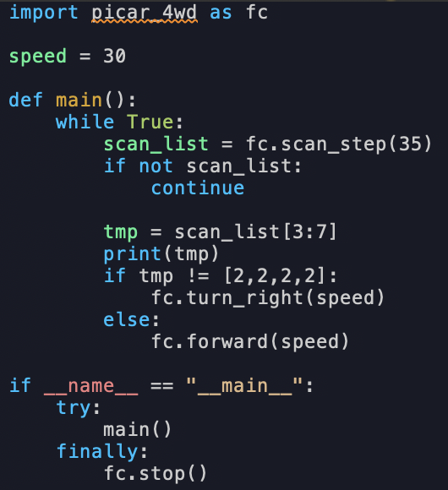

**Figure 9: obstacle-avoidance.py from the picar-4wd repository**

# Part 2

In part 2 of the lab, I implemented the following high-level architecture to combine advanced mapping, object recognition, and path planning functionalities into a single program.

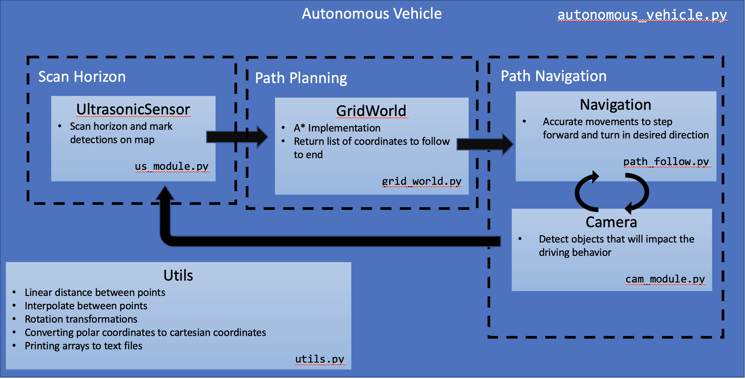

**Figure 10: A High level architecture diagram describing the behavior of the autonomous vehicle program implemented in Lab1 Part 2**

At a high level, the autonomous vehicle program contains a single loop that performs the following sub-functions:

1. Collect ultrasonic readings from the surrounding environments and formalize any detected obstacles by populating a NumPy array, or grid world, with positive integers to represent the objects in the environment.
2. Plan an optimal path from the car’s current location to the destination location that avoids any surrounding obstacles.
3. Incrementally step toward the destination by following the optimized path. During this traversal, take appropriate actions when objects such as pedestrians and/or stop signs are encountered.

The implementation of this main loop is contained within **autonomous_vehicle.py**, and a screenshot of this high-level loop is shown below:

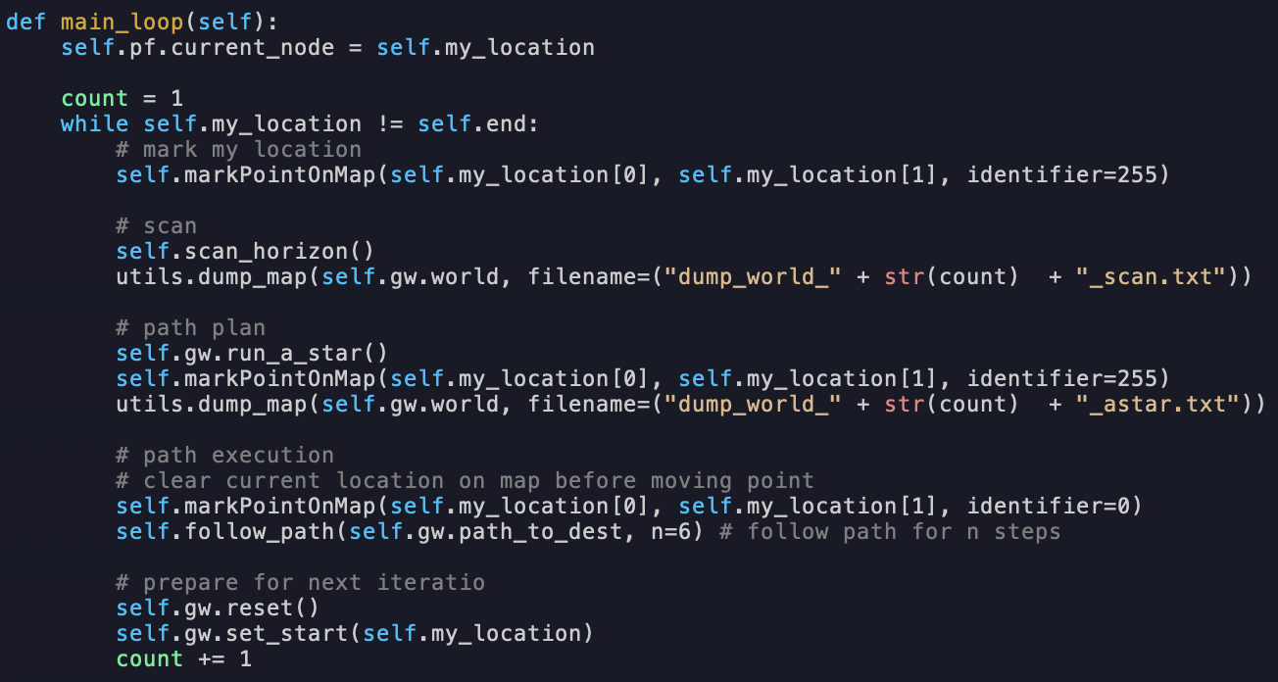

**Figure 11: The main loop of the “autonomous_vehicle” module. In each iteration of this loop the car performs environment scanning, advanced routing, object recognition, and navigation**

## More Advanced Mapping

The ultrasonic sensor was configured to scan the environment in 5-degree increments in a counter-clockwise fashion. Sweeping the environment produced a series of polar coordinates representing obstacles in the environment with respect to the car’s frame of reference. In the main **autonomous_vehicle** class, these polar coordinates underwent a series of translational and rotational transformations to produce cartesian coordinates with respect to the ground reference frame. These cartesian coordinates were then used to index into the grid world NumPy array and write positive integers to indicate obstacles surrounding the car.

The process of sweeping the environment and producing a list of polar coordinates is implemented in **us_module.py**. A portion of this class definition and its member functions which scan the environment and reset the sensor’s position to 90° are shown in Figure 12.

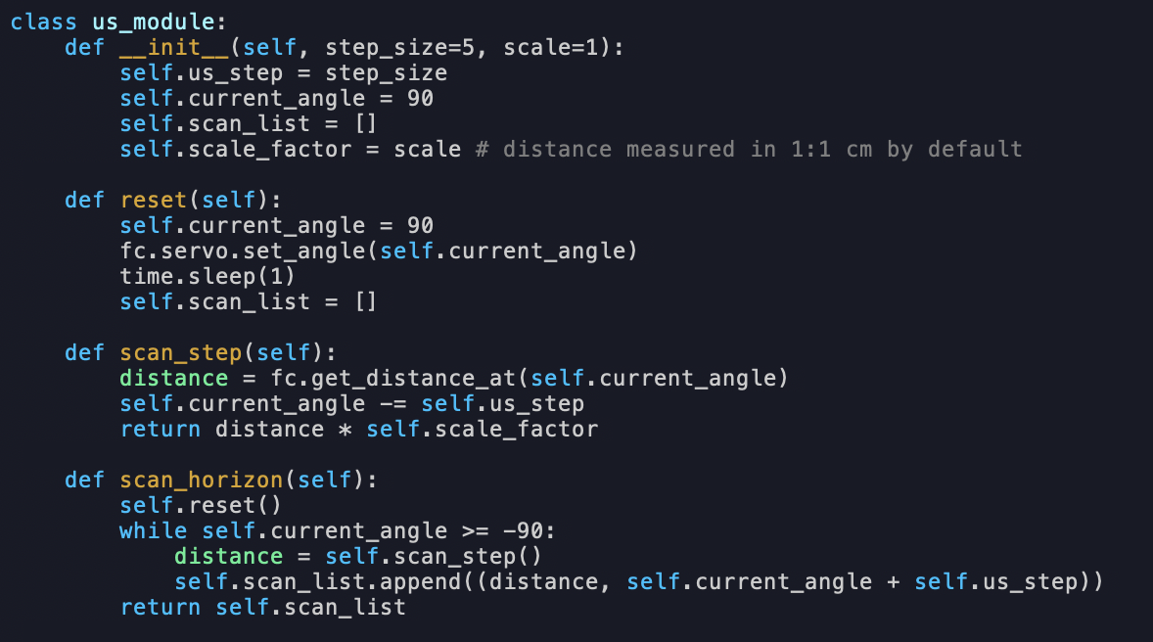

**Figure 12: The ultrasonic sensor class. The method “scan_horizon” is used to produce a series of polar coordinate which help identify obstacles in the car’s surroundings**

The process of translating these readings into grid world coordinates and marking boundaries in the grid world NumPy array were lifted into the primary **autonomous_vehicle** module. This sub-function is shown in Figure 13:

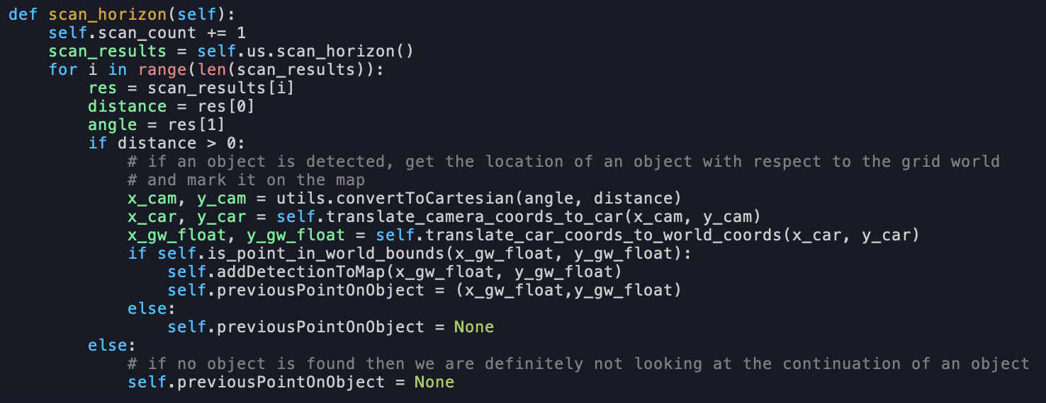

**Figure 13**: **The “scan_horizon” method in *autonomous_vehicle.py* translates the polar coordinate readings from the ultrasonic sensor into cartesian coordinate in the grid world’s reference frame. Linear interpolation of boundaries is also performed**

After each iteration of sweeping the environment, the positive integer written into the grid world array was incremented by one. This allowed me to observe how the car’s understanding of the environment evolved over time. To illustrate this point, consider the following environment:

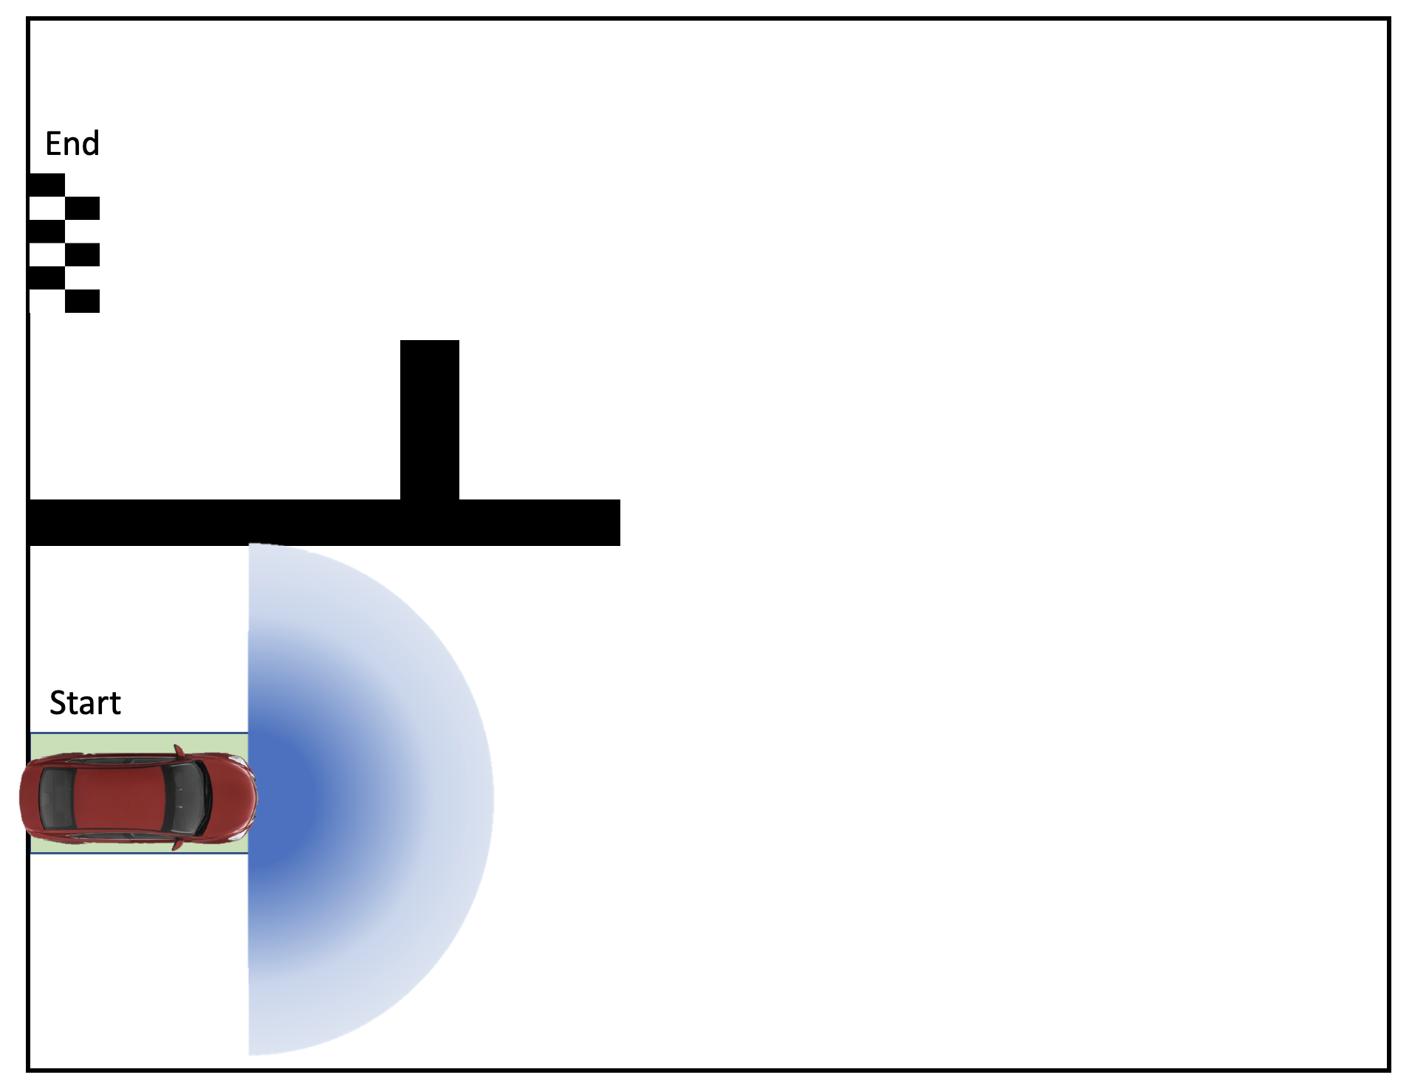

**Figure 14: The ultrasonic sensor, located at the front of the car, captures a 180° view from its mount point on the front of the PiCar**

Due to the initial offset of the ultrasonic sensor from the car’s center, the car was not able to perceive the full length of the boundary adjacent to the car’s left side. This is apparent in the grid world array printout when the car was placed in such a configuration in real life:

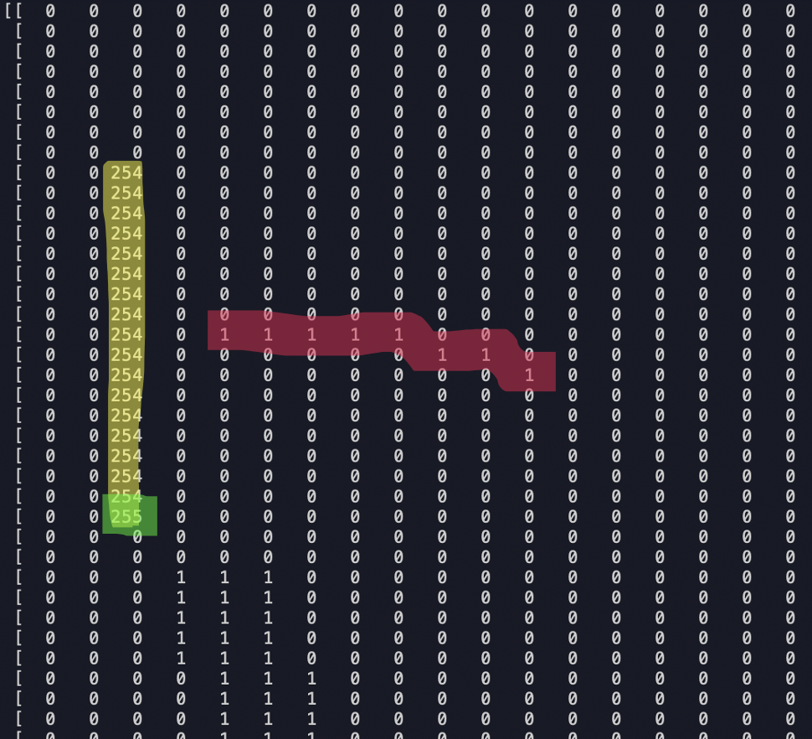

**Figure 15**: **The car’s initial scan of the environment does not capture the full length of an adjacent barrier.**

Here, the red 1s signify the boundary detected in the first iteration of scanning the environment, the green 255 represents the car’s current location, and the yellow 244s represent an optimal path to the destination produced by our path planning algorithm. Because the car does not see the full length of the barrier, the path planning algorithm routes the car to the end location in a straight line. If the car were to take this path, it would drive directly into the barrier. However, once the car turns toward the boundary and performs a second scan of the environment, it captures the full length of the boundary. The car’s new perception of the environment is illustrated in the grid world printout shown in Figure 16, where the orange 2s represent portions of the barrier detected in the second pass of scanning the environment:

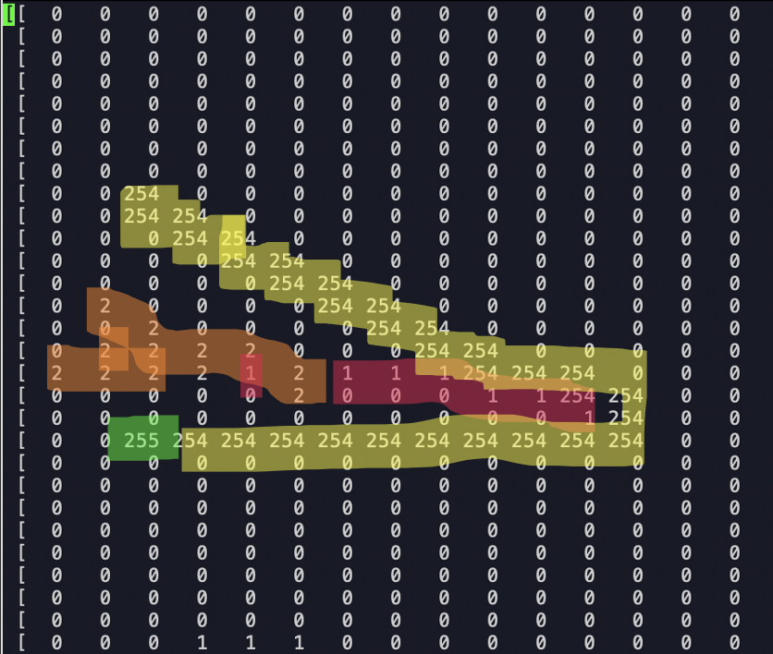

**Figure 16: A second iteration of scanning the environment is shown by new barriers labeled with the number 2. The Path Planning algorithm now routes the car around the barrier.**

Now, the generated path, again shown in yellow 255s, routes the car around the barrier to its destination, avoiding a collision course with the barrier.

Also contained within the “scan_horizon” method of the **autonomous_vehicle** module is the process of interpolating the boundary of an object given discrete points along its border which were picked up by the ultrasonic sensor. To do this, the linear distance between an obstacle detection (an ultrasonic sensor reading with a positive distance value) and the last detected obstacle was calculated and compared to a threshold value of 2 times a global scaling factor--the scaling factor represents the size, in centimeters, of each cell in the grid world. If this condition was met, a utility function was executed to interpolate between the two points and return a series of coordinates which were populated on the grid world. Excerpts from this process are shown in Figure 17 and 18.

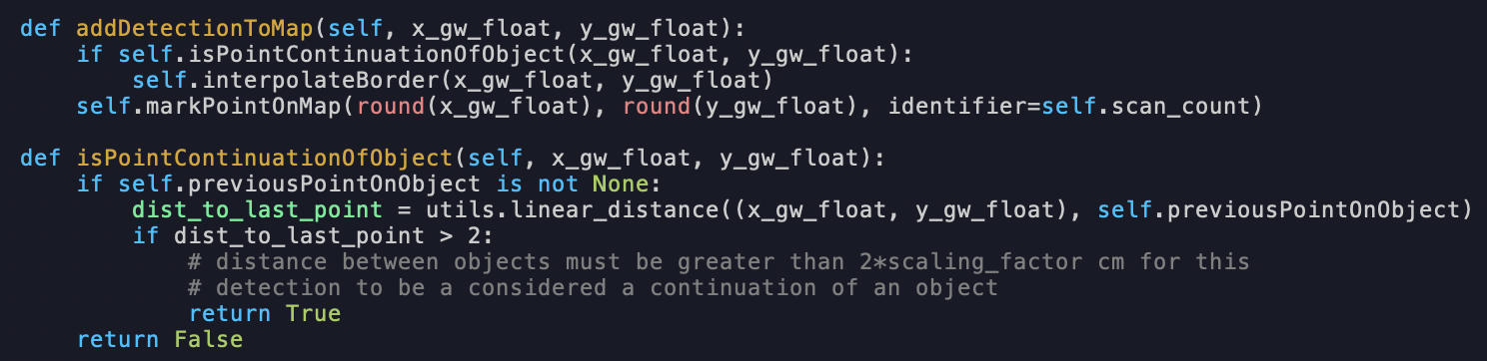

**Figure 17: Adding a new obstacle detections to a map**

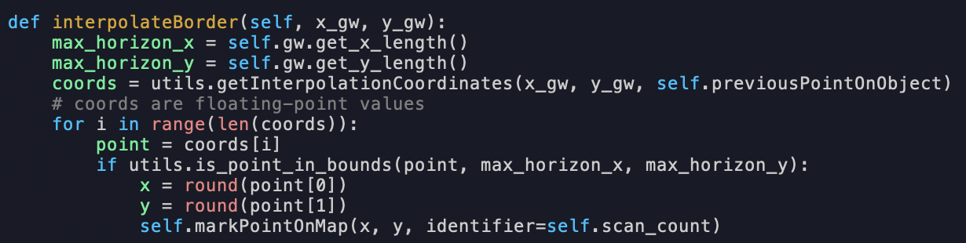

**Figure 18**: **Interpolating a line segment between the input detection coordinates and the coordinates of a previous detection. The grid world NumPy array was marked if necessary**

As seen in Figure 18, the process of calculating coordinates along the line segment formed by two detection points was contained within a utility file called **utils.py**. In this method, I chose to pad the boundary of an obstacle by including coordinates that were 1 cell away from the boundary in the return value. This resulted was that a “thicker” line was drawn on the grid world in between readings. This provided a layer of safety that helped prevent the car from running into walls because the path planning algorithm would avoid cells with positive integer entries. The process of interpolating between points and adding this padding are shown in Figure 19.

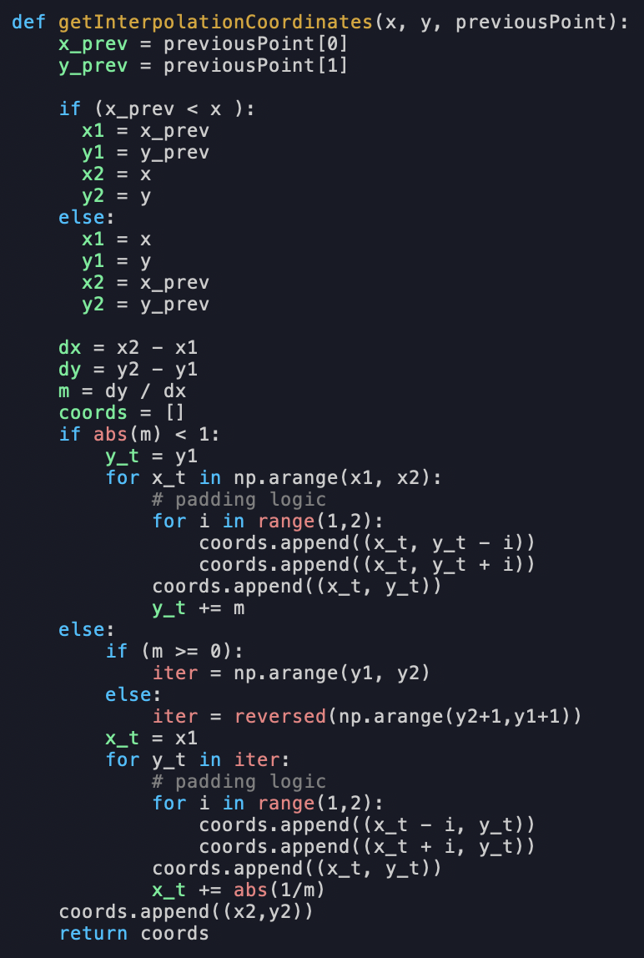

**Figure 19: Interpolating coordinates between two points and padding the line segment**

## Object Detection

As recommended in the lab material, I leveraged OpenCV APIs to perform image manipulation and TensorFlow’s pretrained CNN’s to detect objects in the images captured by the Pi Camera.

Since the Raspberry Pi has limited computational resources, it was necessary to consider the performance of several models when deployed on the Pi. The models I considered to perform object detection included:

* Efficientdet_lite0.tflite
* Efficintdet_lite1.tflite
* Lite-model-efficientdet_lite2_detection_modetadata_1.tflite

These models were selected from the TensorFlow Hub main page after filtering by domain (object detection) and a TFLite model format [5]. By using the TFLite format, the model is better suited for running on low-powered edge devices such as a raspberry pi.

Model performance was compared by considering the frame rate at which images were processed while detecting a stop sign. An experiment was set up whereby each model was passed as an input parameter into the “detect.py” script from the “tensorflow” GitHub page to kick off object recognition [6]. Before displaying the image on screen, bounding boxes were added to the image to verify the stop sign was detected, and the frame rate was printed in the top-left corner of the image. Figure 20 illustrates the performance of each model during this experiment. As seen, the model “efficientdet_lite0.tflite” performed best, with a higher frame compared to the other two models. This model was selected as the object detection model which would be deployed onto the PiCar.

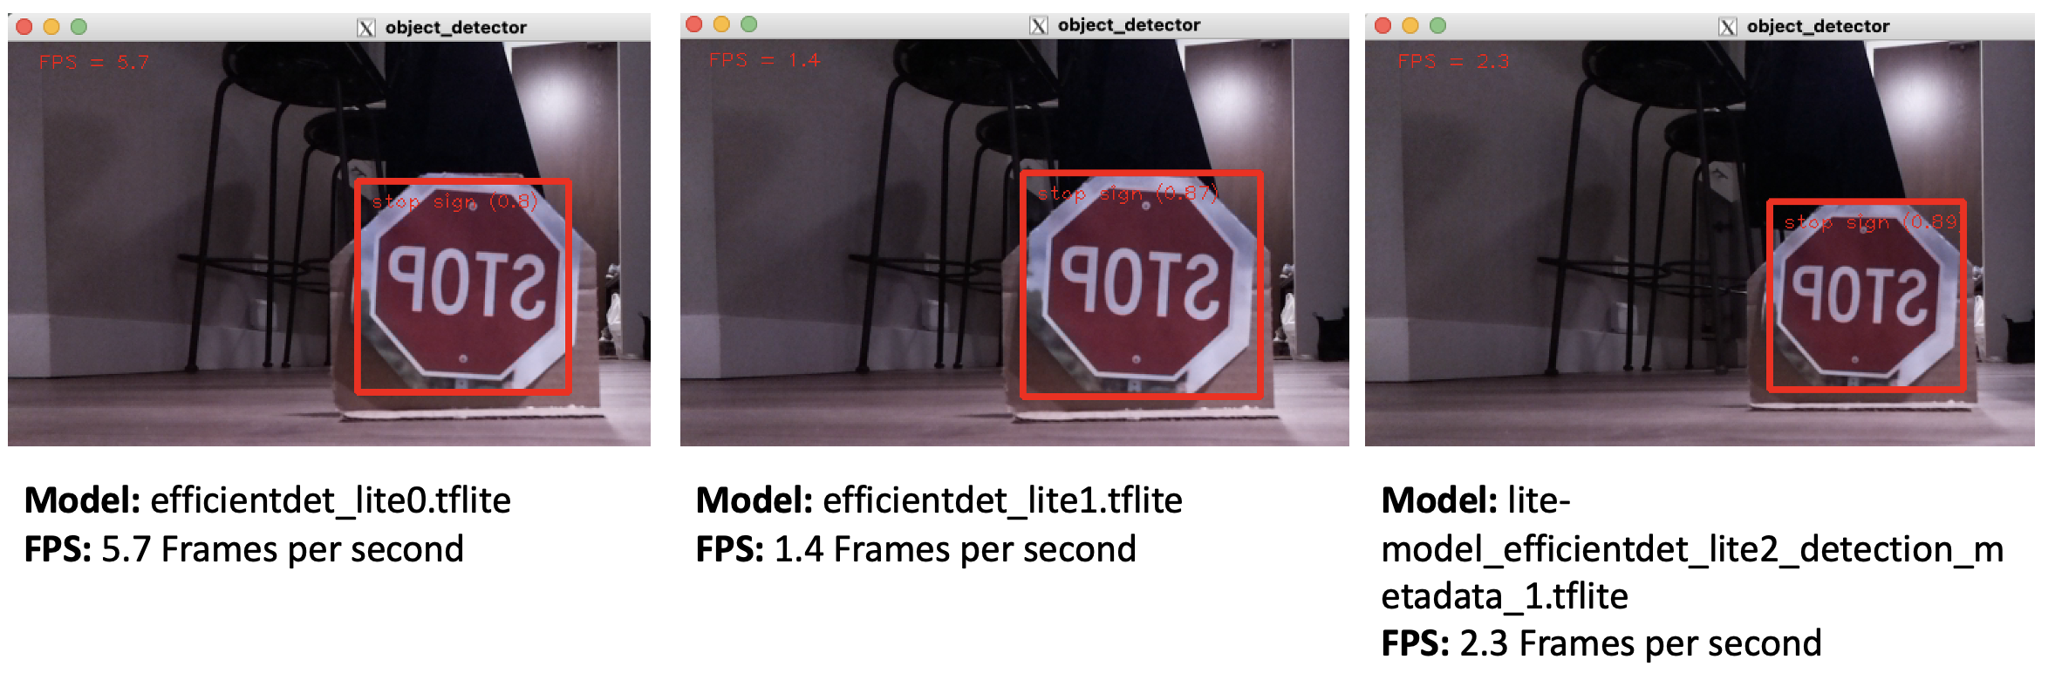

**Figure 20: Comparing the performance of various Object Detection CNN’s based on frame rate**

Another variable considered while assessing model performance was the number of permissible CPU threads to spin up while performing object detection. To test this parameter, I ranged the number of threads from 1 to 4 while again performing object detection of a stop sign. These experiment results are shown in Figure 21. Here, the best performing configuration used a single thread—resulting in 5.7 frames per second. Since the Raspberry Pi 4b only contains 4 CPU cores, I chose not to test higher number of threads for fear of overburdening the Pi with context switching. One interesting observation from this experiment is that two threads performed noticeably worse than both a single thread and four threads.

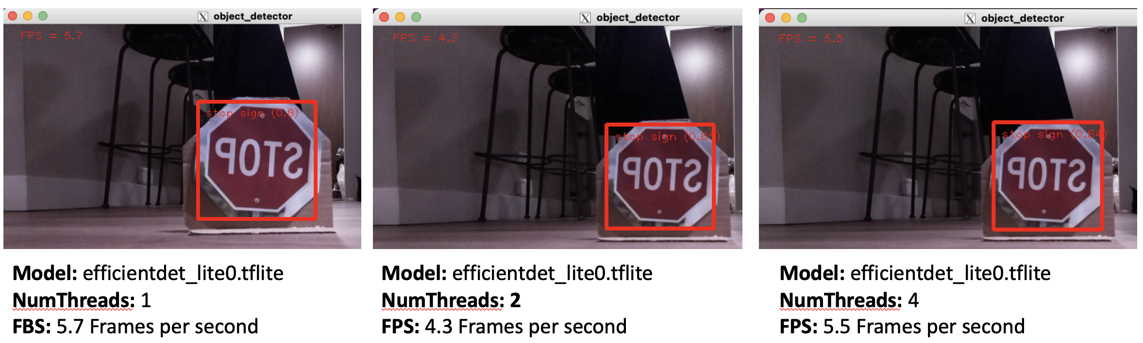

**Figure 21: Assessing object detection model performance with varying degrees of concurrency**

Further improvements to the frame rate may have been achieved by dispatching CNN related tasks to the Videocore VI GPU that exists on the Pi’s Broadcom BCM2711 System on a Chip (SoC). However, this would require that the CNN implementation be suitable for parallelism. Ultimately, this opportunity to enhance performance was not pursued. After reviewing online resources, it seemed that a deep understanding the GPU, the libraries used to interface with the GPU, and an understanding of synchronizing the CPU and GPU tasks were necessary to implement this [7] [8].

In my primary **autonomous_vehicle** python module, object detection was used to identify stop signs and pedestrians. In the python module **cam_module.py**, the function “detect_obstacles” returns a tuple of boolean values indicating whether either of these objects are observed in the car’s path. This code is shown in Figure 22.

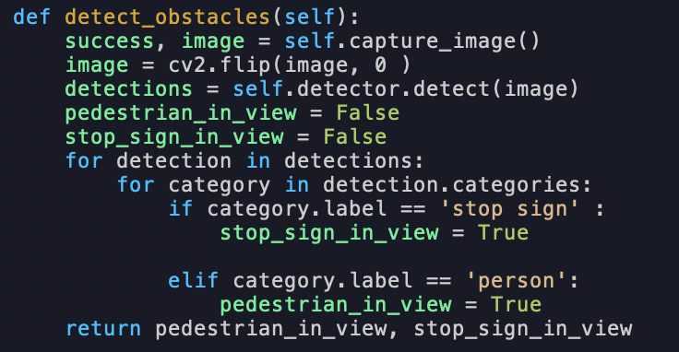

**Figure 22: Performing object detection on PiCamera readings to identify stop signs and pedestrians in front of the car**

## Self-Driving Navigation (Routing)

The A* Search Algorithm produces an optimal path between the car’s current location and the destination. In each cycle of the autonomous vehicle’s high-level loop, the algorithm is re-run given the updated grid world environment. In this manner, the car is continuously adapting to its environment as illustrated in Figures 15 and 16.

The A* implementation, contained in **grid_world.py**, uses a heuristic function (*hcos*t) which calculates the linear distance between a given node and the car’s destination node. The gcost function returns the number of hops between a given node on the grid world and the starting node. By minimizing the sum of both gcost and *hcos*t functions, the algorithm is attempting to select as direct of a path to a destination while minimizing the time spent traveling. A video published by Sebastian Lague on YouTube.com was referenced while programing this algorithm, and a snippet of my implementation is shown below in Figure 23[9]:

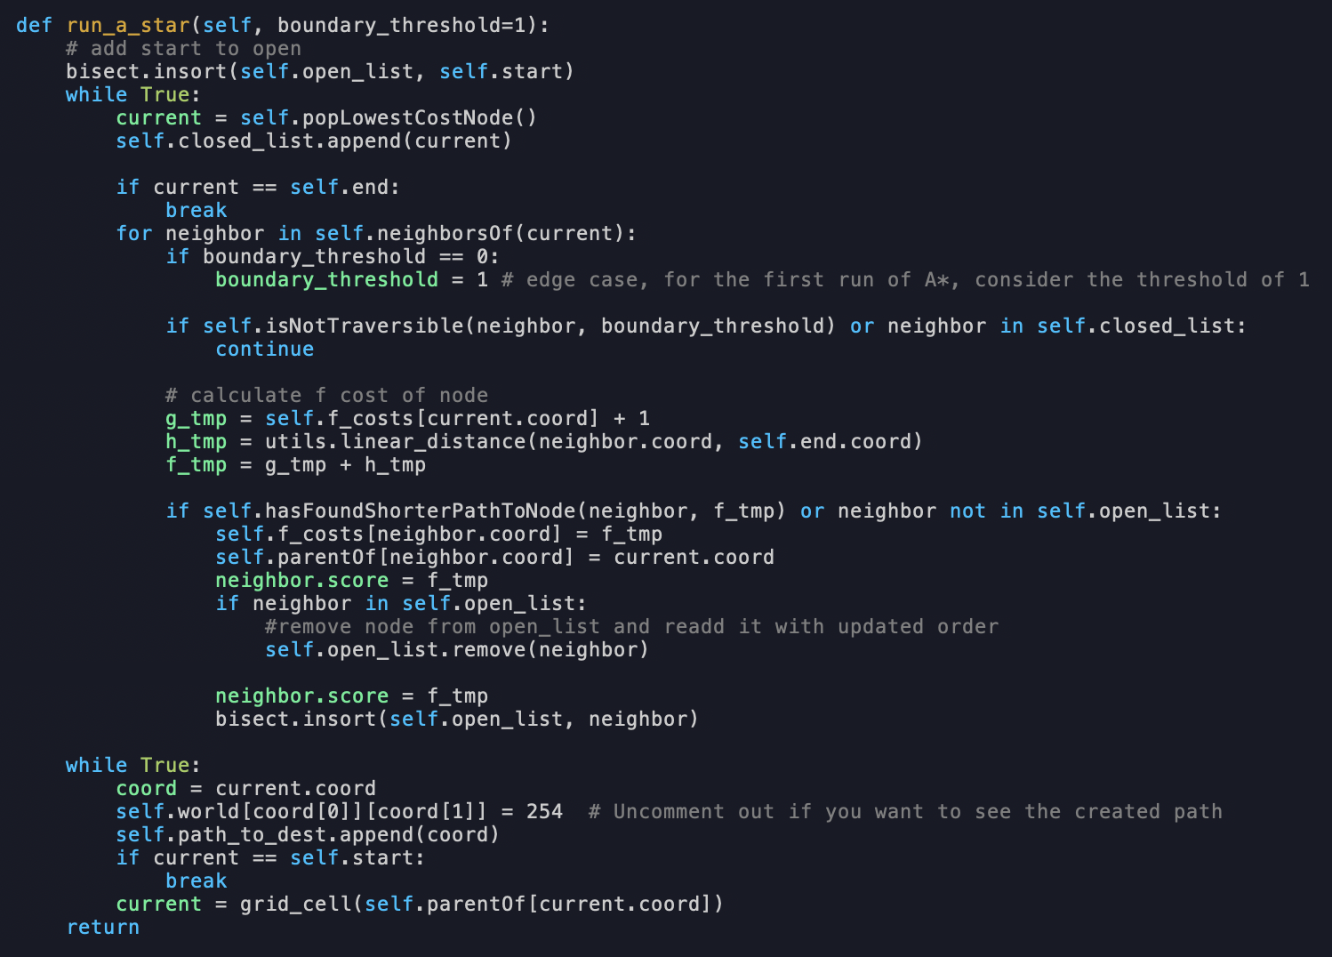

**Figure 23: A* Implementation in grid_world.py**

Here, A* only considers the set of indices that are directly north, west, south, and east as traversable neighbors of the car. A drawing of this behavior is shown in Figure 24, where the car’s cell is in green, and the set of neighbors is shown in yellow:

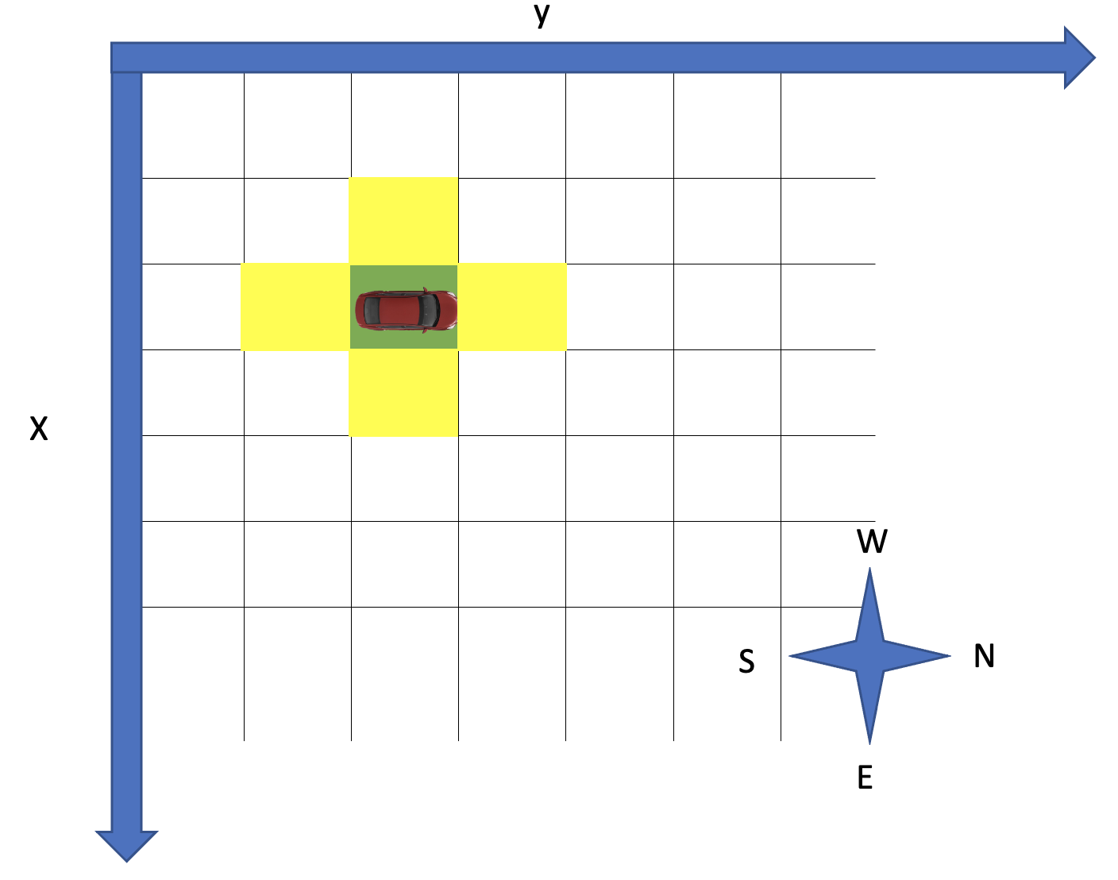

**Figure 24: The set of neighbors consider by the A* algorithm includes adjacent cells**

Programmatically, the process of generating a series of neighboring cells is implemented in the member function “neighborsOf” of **grid_world.py**, shown in Figure 25.

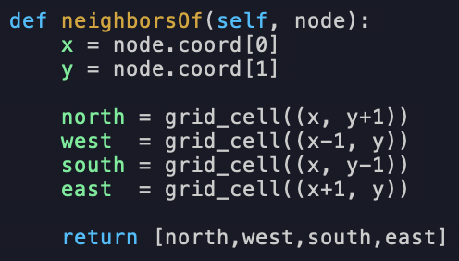

**Figure 25: Generating a set of neighboring indices in the A* Path Planning implementation**

Similar to how the servomotor on which the ultrasonic sensor was mounted was reset to 90° before capturing a new series of recordings, I implemented a reset function in the **grid_world** module which cleared the optimal path and the open and closed list data structures that are integral in the A* implementation. By doing so, I prepared the path planning module to accept new information about the car’s current location and any new obstacles in the environment before recomputing the optimal path. This evolution of the optimal path is also illustrated in Figures 15 and 16. In these figures, the optimal path routes the car around the barrier blocking it from the destination after it perceives its existence. A snipped of the reset method is shown in Figure 26.

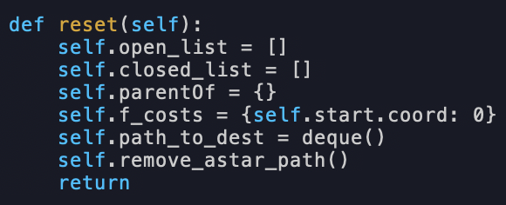

**Figure 26: Resetting the grid_world module in preparation of recalculating an optimal path**

## Putting it all together

The last portion of the lab pieced together routing, object detection, and environment scanning to provide a truly autonomous navigation system.

As previously described, the ultrasonic sensor and path planning modules worked seamlessly well together. New information regarding the environment was passed to the grid_world module in the form of an up-to-date NumPy array which was used to process an optimal path between the car’s current location and the destination. The optimal path was then handed to the navigation module to move the car along the path.

At this point, I added a method to the **autonomous_vehicle** module which cycled between searching for traffic related objects in front of the car and moving the car along the optimal path. This process primarily used the “detect_obstacles” method in **cam_module.py** and the “move_to_next_coord” method from **path_follow.py** to accomplish this task.

The traffic rules in place for the purpose for the lab are described in Figure 27.

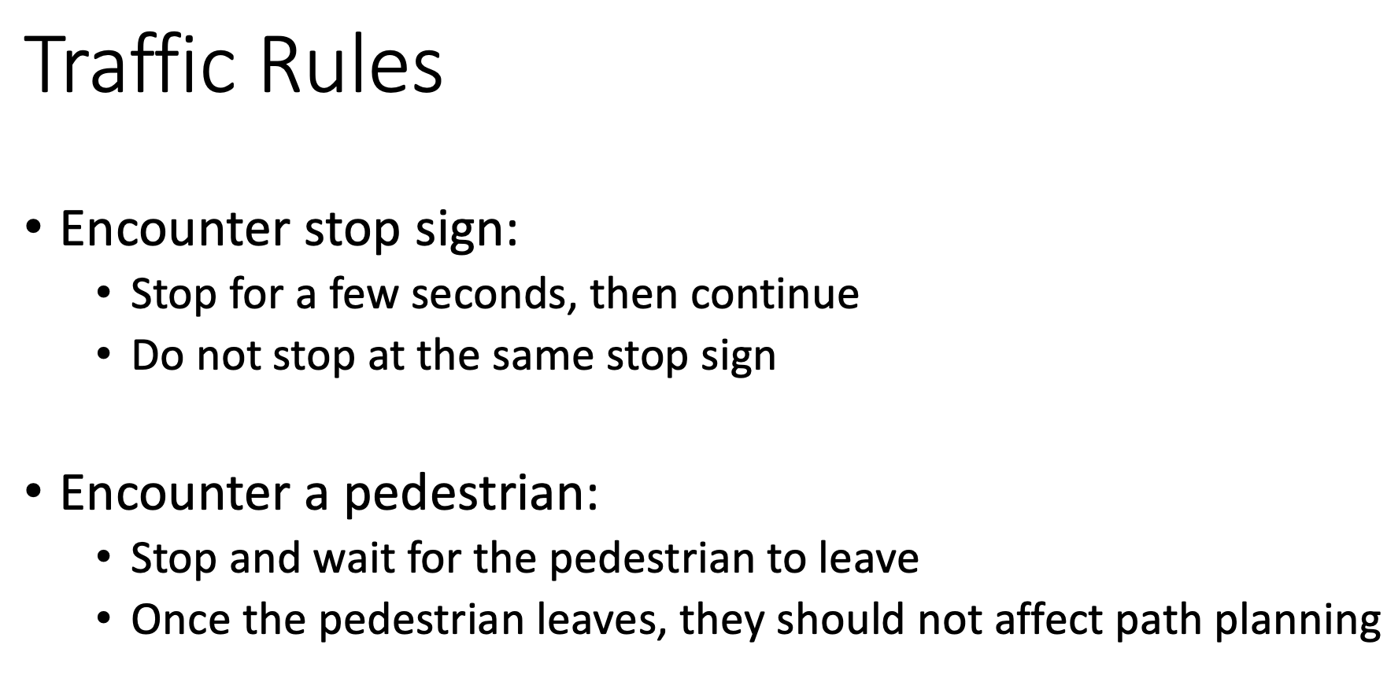

**Figure 27: Traffic rules followed by the PiCar**

At a high level, these scenarios were handled by using the **time** pythonmoduleto temporarily pause program execution before proceeding to move the car along its path. If a stop sign were encountered, the car would pause for five seconds and continue moving. If a pedestrian were encountered, it would pause for one second and re-poll the camera module in a loop until the pedestrian had finally left the frame.

There were additional subtleties in each scenario worth noting. In the case of detecting a traffic sign, I wanted to prevent the car from stopping at the same stop sign if it were detected in successive steps. To achieve this, I added a counter variable to this method that would be reset to 0 any time that a stop sign was first encountered. In successive steps of moving the car, the counter would increment by one. Only when the counter reached a value greater than 15 (i.e., the car had taken 15 steps) could a new detection of a stop sign trigger the car to stop at that stop sign. Figuratively speaking, this means that the car would consider two images of stop signs to point to the same stop sign if they were captured within a short amount of time of one another.

In the scenario where a pedestrian stood in front of the car, I wanted the car to understand that the pedestrian was only a temporary obstacle which would not impede the car’s path once the pedestrian moved away. As an example, consider the environment configuration in figure 28. While the pedestrian is in view of the car, the car should not move forward for fear of hitting the pedestrian. Once the pedestrian leaves, it is desirable that the car proceed to a destination in a straight line since no barrier exists along the path.

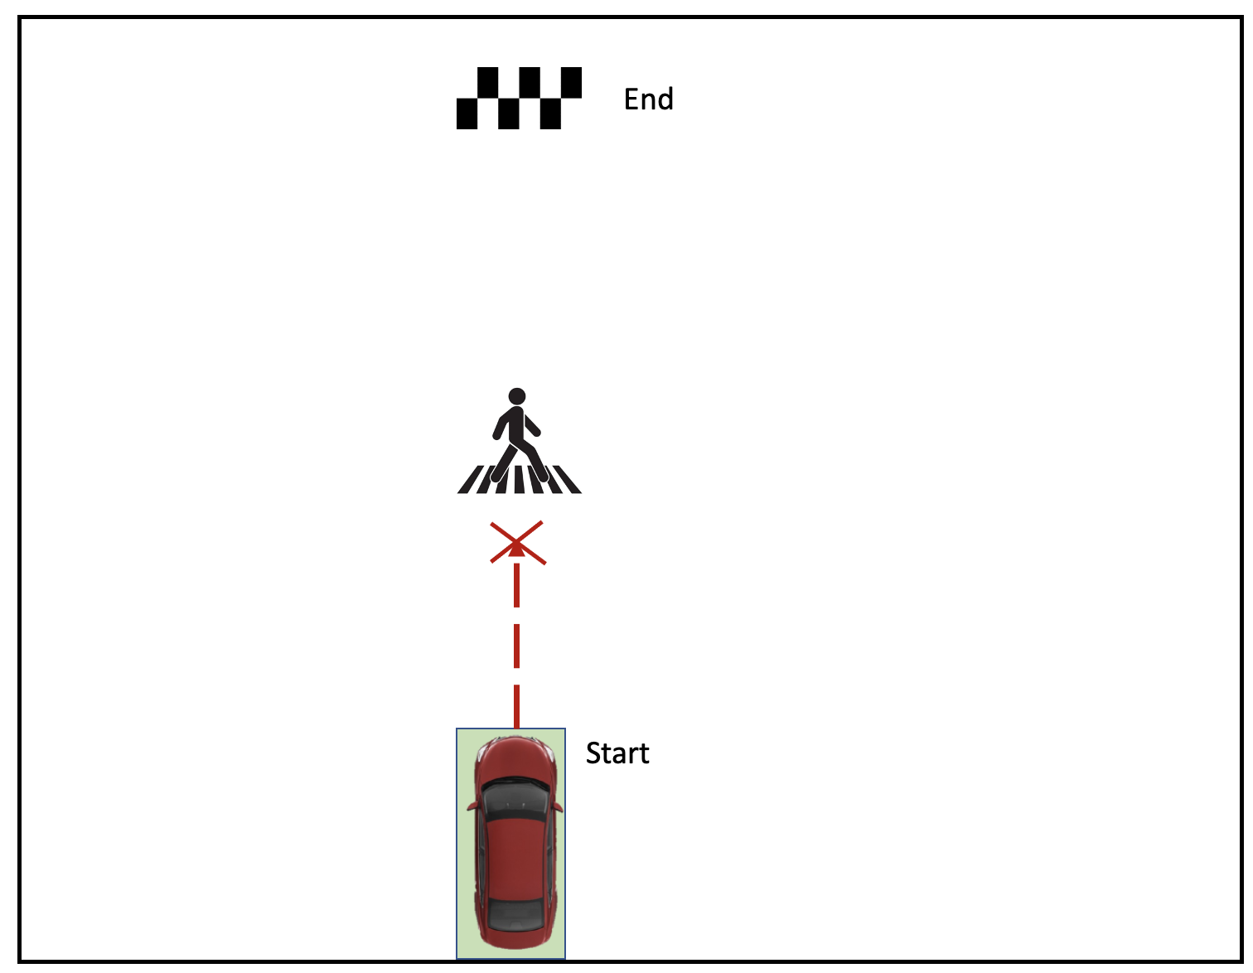



**Figure 28: An environment configuration where a pedestrian blocks the car’s path to a destination**

Unfortunately, the ultrasonic sensor is unable to distinguish between a person and any other barrier in an environment, and it marks points on the grid world NumPy array to indicate an obstacle in the map. The A* path planning algorithm then routes the car around the location where the person previously resided. The following grid world printout, produced with the car in the same configuration in real life, illustrates this point:

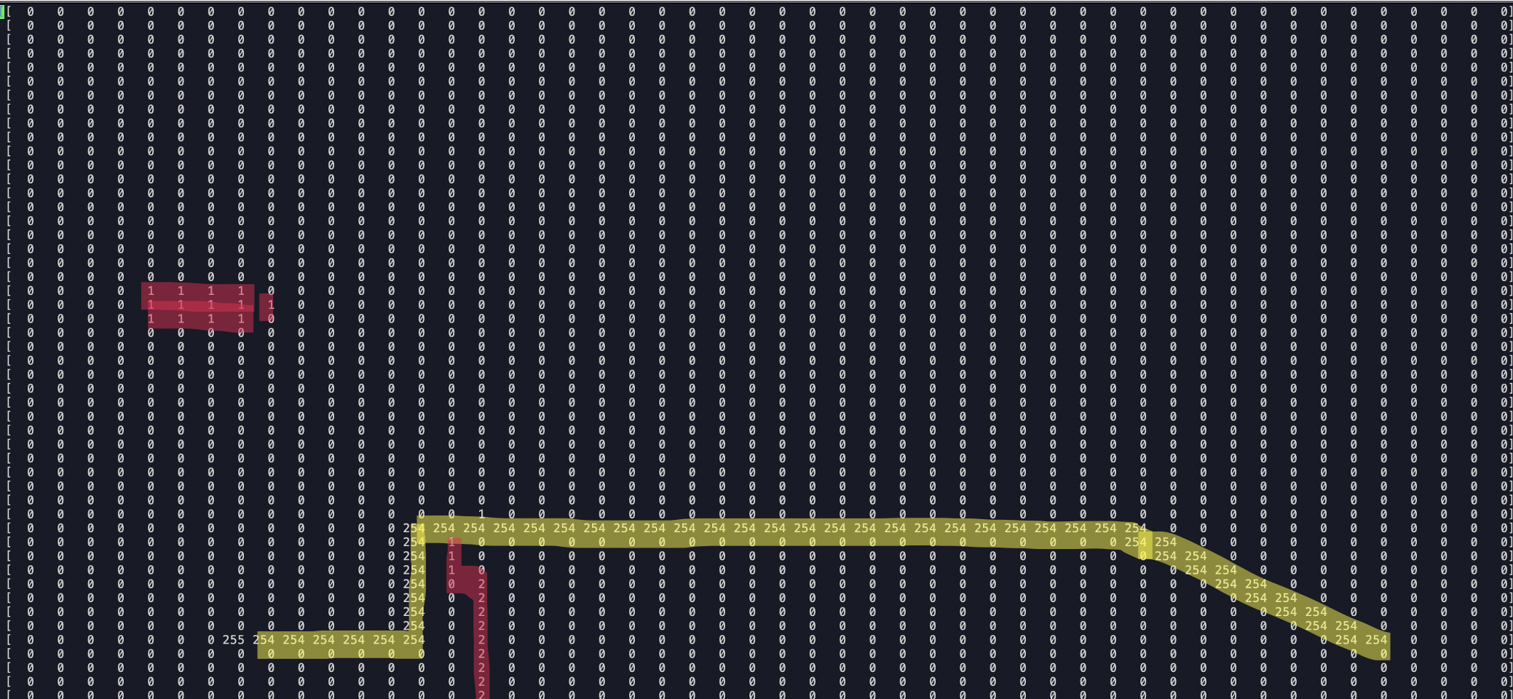

**Figure 29: A* routes the car around a pedestrian’s location after the pedestrian leaves the environment**

To prevent A* from routing the car around the location of the pedestrian after it is removed from the environment, I added a method to the **grid_world** module to remove boundary detections from the grid world NumPy array directly in front of the car. This is justifiable by considering that the car’s camera only captures a small sector of the 360° surroundings, and this view is directly in front of the car. We can therefore assume that when a pedestrian is detected by the camera module, any obstacles identified in front of the car by the ultrasonic sensor correspond to the pedestrian. These boundary markings can be removed from the map once the person is no longer detected by the camera.

After clearing these boundaries, A* correctly routes the car to its destination in a straight path, as shown in the grid world printout in Figure 30.

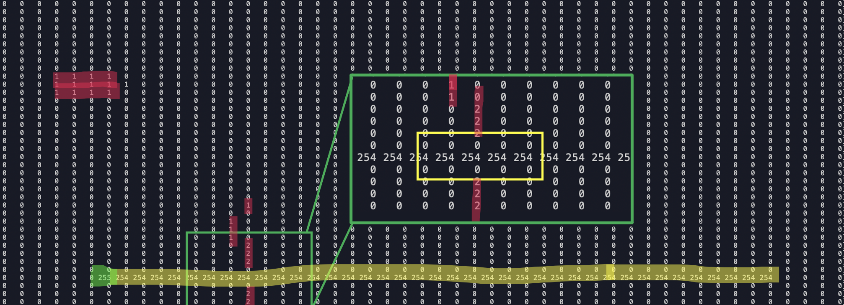

**Figure 30: A* path produced after clearing a portion of the grid world boundaries directly in front of the car**

The implementation of this path-following process is contained within “follow_path” inside **autonomous_vehicle.py**, and a screen capture is shown in Figure 31.

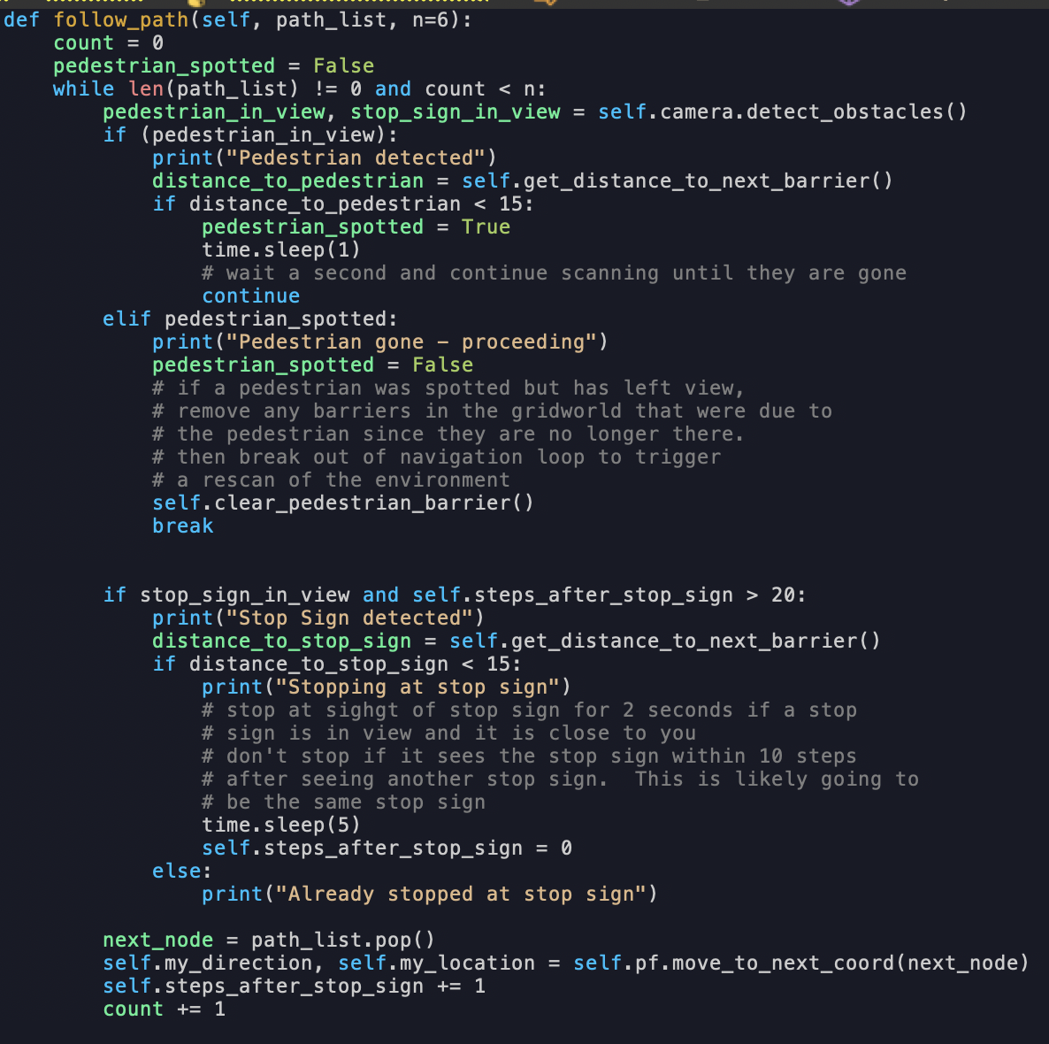

**Figure 31: Navigating an optimal path while applying traffic logic in autonomous_vehicle.py**

With environment scanning, path planning, and navigation now implemented, the car was able to successfully navigate the environment configuration shown in Figure 32. This navigation is demoed in the accompanying video for this lab submission:



**Figure 32: The final environment configuration the PiCar navigated, containing obstacles and traffic signs**

# References

[1] Sunfounder User manual. <https://github.com/sunfounder/picar-4wd/blob/master/docs/Picar-4wd%20User%20Manual.pdf>

[2] Twisted Pair Wiring - <https://en.wikipedia.org/wiki/Twisted_pair>

[3] PiCar-4wd GitHub repo - <https://github.com/sunfounder/picar-4wd>

[4] Lab 1 material - <https://docs.google.com/document/d/1pxzkC9UOPHBr24PRmHCYh3iSYBfWYOAvCHy5_Pd2p-I/edit#heading=h.n38puu4zwmlw>

[5] TensorFlow Hub- <https://tfhub.dev/>

[6] TensorFlow Detect.py Example - <https://github.com/tensorflow/examples/blob/master/lite/examples/object_detection/raspberry_pi/README.md>

[7] How to Optimize Raspberry Pi code using its GPU. Warden, Pete. <https://github.com/tensorflow/examples/blob/master/lite/examples/object_detection/raspberry_pi/README.md>

[8] Towards GPU-accelerated image classification on low-end hardware. Instradrum. <https://github.com/tensorflow/examples/blob/master/lite/examples/object_detection/raspberry_pi/README.md>

[9] Sebastian Lague. A* Pathfinding (E01: algorithm explanation) - <https://youtu.be/-L-WgKMFuhE?t=587>

[10] TensorFlow object_detectory.py Example - <https://github.com/tensorflow/examples/blob/master/lite/examples/object_detection/raspberry_pi/object_detector.py>

[11] IoT Lab 1 Personal GitHub repo - <https://github.com/jwennerstrum1/iot_lab1>

# Appendix

1. **autonomous_vehicle.py – The high level autonomous vehicle program**

|  |
| --- |
| import time  import utils  import picar_4wd as fc  import us_module as us  from grid_world import grid_world  import path_follow as pf  import sys  import pdb  import numpy as np  import cam_module  class autonomous_vehicle:  # scale_factor = the size of each grid cell in the grid world (in cm)  def __init__(self, start=(25,0), end=(8,0), world_size=(50,50), scale_factor=5, starting_direction=utils.direction.NORTH, turn_time=1.3):  if start[0] < 0 or start[0] >= world_size[0] or start[1] < 0 or start[1] >= world_size[1]:  print("ERROR: start coordinate not in bounds")  sys.exit(0)      if end[0] < 0 or end[0] >= world_size[0] or end[1] < 0 or end[1] >= world_size[1]:  print("ERROR: end coordinate not in bounds")  sys.exit(0)    self.scale_factor = scale_factor  self.gw = grid_world(np.zeros(world_size, dtype=np.uint8), start, end)  self.previousPointOnObject = None  self.my_location = start  self.my_direction = starting_direction  self.end = end  self.us = us.us_module(step_size=5, scale = 1/scale_factor) # angle step, not grid cell length  self.pf = pf.navigation_module(step_size = scale_factor, direction=starting_direction, turn_time=turn_time)  self.scan_count=0  self.steps_after_stop_sign = np.inf  self.camera = cam_module.camera()  def translate_car_coords_to_world_coords(self, x_car, y_car):  rotation_angle = ((self.my_direction + 1) % 4) * 90  x_c1, y_c1 = utils.rotation_transform(rotation_angle, (x_car, y_car))  x_gw = x_c1 + self.my_location[0]  y_gw = y_c1 + self.my_location[1]  return x_gw, y_gw  def translate_camera_coords_to_car(self, x_cam, y_cam):  x_car = x_cam + 10.16 * 1/self.scale_factor  y_car = y_cam  return x_car, y_car  def is_point_in_world_bounds(self, x_gw,y_gw):  max_horizon_x = self.gw.get_x_length()  max_horizon_y = self.gw.get_y_length()  return utils.is_point_in_bounds((x_gw, y_gw), max_horizon_x, max_horizon_y)    def scan_horizon(self):  self.scan_count += 1  scan_results = self.us.scan_horizon()  for i in range(len(scan_results)):  res = scan_results[i]  distance = res[0]  angle = res[1]  if distance > 0:  # if an object is detected, get the location of an object with respect to the grid world  # and mark it on the map  x_cam, y_cam = utils.convertToCartesian(angle, distance)  x_car, y_car = self.translate_camera_coords_to_car(x_cam, y_cam)  x_gw_float, y_gw_float = self.translate_car_coords_to_world_coords(x_car, y_car)  if self.is_point_in_world_bounds(x_gw_float, y_gw_float):  self.addDetectionToMap(x_gw_float, y_gw_float)  self.previousPointOnObject = (x_gw_float,y_gw_float)  else:  self.previousPointOnObject = None  else:  # if no object is found then we are definitely not looking at the continuation of an object  self.previousPointOnObject = None  def addDetectionToMap(self, x_gw_float, y_gw_float):  if self.isPointContinuationOfObject(x_gw_float, y_gw_float):  self.interpolateBorder(x_gw_float, y_gw_float)  self.markPointOnMap(round(x_gw_float), round(y_gw_float), identifier=self.scan_count)  def isPointContinuationOfObject(self, x_gw_float, y_gw_float):  if self.previousPointOnObject is not None:  dist_to_last_point = utils.linear_distance((x_gw_float, y_gw_float), self.previousPointOnObject)  if dist_to_last_point > 2:  # distance between objects must be greater than 2*scaling_factor cm for this  # detection to be a considered a continuation of an object  return True  return False    def markPointOnMap(self,x_gw, y_gw, identifier=1):  self.gw.world[int(x_gw)][int(y_gw)] = identifier  def interpolateBorder(self, x_gw, y_gw):  max_horizon_x = self.gw.get_x_length()  max_horizon_y = self.gw.get_y_length()  coords = utils.getInterpolationCoordinates(x_gw, y_gw, self.previousPointOnObject)  # coords are floating-point values  for i in range(len(coords)):  point = coords[i]  if utils.is_point_in_bounds(point, max_horizon_x, max_horizon_y):  x = round(point[0])  y = round(point[1])  self.markPointOnMap(x, y, identifier=self.scan_count)  def follow_path(self, path_list, n=6):  count = 0  pedestrian_spotted = False  while len(path_list) != 0 and count < n:  pedestrian_in_view, stop_sign_in_view = self.camera.detect_obstacles()  if (pedestrian_in_view):  print("Pedestrian detected")  distance_to_pedestrian = self.get_distance_to_next_barrier()  if distance_to_pedestrian < 15:  pedestrian_spotted = True  time.sleep(1)  # wait a second and continue scanning until they are gone  continue  elif pedestrian_spotted:  print("Pedestrian gone - proceeding")  pedestrian_spotted = False  # if a pedestrian was spotted but has left view,  # remove any barriers in the gridworld that were due to  # the pedestrian since they are no longer there.  # then break out of navigation loop to trigger  # a rescan of the environment  self.clear_pedestrian_barrier()  break      if stop_sign_in_view and self.steps_after_stop_sign > 20:  print("Stop Sign detected")  distance_to_stop_sign = self.get_distance_to_next_barrier()  if distance_to_stop_sign < 15:  print("Stopping at stop sign")  # stop at sighgt of stop sign for 2 seconds if a stop  # sign is in view and it is close to you  # don't stop if it sees the stop sign within 10 steps  # after seeing another stop sign. This is likely going to  # be the same stop sign  time.sleep(5)  self.steps_after_stop_sign = 0  else:  print("Already stopped at stop sign")    next_node = path_list.pop()  self.my_direction, self.my_location = self.pf.move_to_next_coord(next_node)  self.steps_after_stop_sign += 1  count += 1  def clear_pedestrian_barrier(self):  self.gw.remove_barriers_in_path(self.my_location, self.my_direction)    def get_distance_to_next_barrier(self):  distance_to_barrier = self.gw.get_distance_to_closest_barrier(self.my_location, self.my_direction)  return distance_to_barrier      def main_loop(self):  self.pf.current_node = self.my_location    count = 1  while self.my_location != self.end:  # mark my location  self.markPointOnMap(self.my_location[0], self.my_location[1], identifier=255)    # scan  self.scan_horizon()  utils.dump_map(self.gw.world, filename=("dump_world_" + str(count) + "_scan.txt"))  # path plan  self.gw.run_a_star()  self.markPointOnMap(self.my_location[0], self.my_location[1], identifier=255)  utils.dump_map(self.gw.world, filename=("dump_world_" + str(count) + "_astar.txt"))  # path execution  # clear current location on map before moving point  self.markPointOnMap(self.my_location[0], self.my_location[1], identifier=0)  self.follow_path(self.gw.path_to_dest, n=6) # follow path for n steps  # prepare for next iteratio  self.gw.reset()  self.gw.set_start(self.my_location)  count += 1      if __name__ == "__main__":  # a = autonomous_vehicle(scale_factor = 5, world_size=(20,15), start=(14,0), end=(5,0))  # a = autonomous_vehicle(world_size=(50,50), start=(25,2), end=(8,2), scale_factor=5, starting_direction=utils.direction.NORTH, turn_time=1.25) # WESTWARD  # a = autonomous_vehicle(world_size=(50,50), end=(25,2), start=(8,2), scale_factor=5, starting_direction=utils.direction.NORTH, turn_time=1.25)  # a = autonomous_vehicle(world_size=(50,50), end=(45,2), start=(8,2), scale_factor=5, starting_direction=utils.direction.NORTH, turn_time=1.25) # EASTWARD  a = autonomous_vehicle(world_size=(50,50), start=(45,2), end=(45,30), scale_factor=5, starting_direction=utils.direction.NORTH, turn_time=1.25) # EASTWARD  a.main_loop() |

1. **path_follow.py – The navigation module with helper methods to move the car**

|  |
| --- |
| import picar_4wd as fc  import time  import numpy as np  from collections import deque  import math  from enum import IntEnum  import pdb  import utils  # -----> y  # |  # |  # V  # x  #0 NORTH (+y)  #1 WEST (-x)  #2 SOUTH (-y)  #3 EAST (+x)  # gw = gw_driver.driver()  # class direction(IntEnum):  # NORTH=0  # WEST=1  # SOUTH=2  # EAST=3  class navigation_module:  def __init__(self, turn_time=1.3, avg_speed=25, step_size=5, direction=utils.direction.NORTH):  self.turn_time = turn_time  self.avg_speed = avg_speed # in cm/sec at power 1  self.step_size = step_size # in cm  self.turn_funcs = [self.turn_left, self.turn_right]  self.current_direction = direction  self.current_node = None  def set_current_node(self, node):  self.current_node = node    def turn_right(self, current_direction):  fc.turn_left(1) # due to a bug with picar  time.sleep(self.turn_time + 0.1)  fc.stop()  return utils.direction((current_direction + 4 - 1) % 4)  def turn_left(self, current_direction):  fc.turn_right(1) # due to a bug with picar  time.sleep(self.turn_time)  fc.stop()  return utils.direction((current_direction + 1) % 4)  def step_forward(self, num_steps):  pause_time = num_steps * self.step_size / self.avg_speed  fc.backward(1) # due to a bug with picar  time.sleep(pause_time)  fc.stop()  time.sleep(0.1)  def move_to_next_coord(self, next_node):  self.current_direction = self.face_next_node(next_node)  self.current_node = next_node  self.step_forward(1)  return self.current_direction, self.current_node  def face_next_node(self, next_node):  idx = self.get_turn_idx(next_node)  if idx is None:  return self.current_direction  time.sleep(0.1)  new_direction = self.turn_funcs[idx](self.current_direction)  time.sleep(0.1)  return new_direction    def get_turn_idx(self, next_node):  dx = next_node[0] - self.current_node[0]  dy = next_node[1] - self.current_node[1]  if abs(dx) > 0:  if self.current_direction == utils.direction.WEST or self.current_direction == utils.direction.EAST:  return  tmp = self.current_direction + dx + 1  elif abs(dy) > 0:  if self.current_direction == utils.direction.NORTH or self.current_direction == utils.direction.SOUTH:  return  tmp = self.current_direction + dy  else:  return  idx = (tmp // 2) % 2  return idx |

1. **grid_world.py – Path Planning module, leveraging A\***

|  |
| --- |
| # reference: https://youtu.be/-L-WgKMFuhE?t=587  # g-cst = distance from starting node (captures how long the path is)  # h-cst = distance from the end node  # f-cst = g-cst + h-cst  import utils  import numpy as np  import math  import pdb  import bisect  from collections import deque  class grid_world:  def __init__(self, world, start, end):  self.open_list = [] # SORTED list of open nodes  self.closed_list = [] # UNSORTED list of open nodes  self.parentOf = {} # Dictionary between coordinates (TUPLE) and coordinates (TUPLE)  self.x_dim = len(world)  self.y_dim = len(world[0])  self.start = grid_cell(start)  self.end = grid_cell(end)  self.world = world  self.f_costs = {start: 0} # Dictionary between coordinates (TUPLE) and value (double)  self.path_to_dest = deque()  def reset(self):  self.open_list = []  self.closed_list = []  self.parentOf = {}  self.f_costs = {self.start.coord: 0}  self.path_to_dest = deque()  self.remove_astar_path()  return  def remove_astar_path(self):  x,y= np.where(self.world == 254)  for i in range(len(x)):  self.world[x[i]][y[i]] = 0  return  def set_start(self, start_coord):  self.start = grid_cell(start_coord)  self.f_costs = {start_coord: 0} # set the initial f_cost  return  def run_a_star(self, boundary_threshold=1):  # add start to open  bisect.insort(self.open_list, self.start)  while True:  current = self.popLowestCostNode()  self.closed_list.append(current)  if current == self.end:  break  for neighbor in self.neighborsOf(current):  if boundary_threshold == 0:  boundary_threshold = 1 # edge case, for the first run of A*, consider the threshold of 1    if self.isNotTraversible(neighbor, boundary_threshold) or neighbor in self.closed_list:  continue  # calculate f cost of node  g_tmp = self.f_costs[current.coord] + 1  h_tmp = utils.linear_distance(neighbor.coord, self.end.coord)  f_tmp = g_tmp + h_tmp  if self.hasFoundShorterPathToNode(neighbor, f_tmp) or neighbor not in self.open_list:  self.f_costs[neighbor.coord] = f_tmp  self.parentOf[neighbor.coord] = current.coord  neighbor.score = f_tmp  if neighbor in self.open_list:  #remove node from open_list and readd it with updated order  self.open_list.remove(neighbor)  neighbor.score = f_tmp  bisect.insort(self.open_list, neighbor)    while True:  coord = current.coord  self.world[coord[0]][coord[1]] = 254 # Uncomment out if you want to see the created path  self.path_to_dest.append(coord)  if current == self.start:  break  current = grid_cell(self.parentOf[current.coord])  return    def hasFoundShorterPathToNode(self, node, newCost):  if node.coord in self.f_costs:  costOnRecord = self.f_costs[node.coord]  if newCost < costOnRecord:  return True  return False  def popLowestCostNode(self):  item = self.open_list.pop()  return item  def neighborsOf(self, node):  x = node.coord[0]  y = node.coord[1]  north = grid_cell((x, y+1))  west = grid_cell((x-1, y))  south = grid_cell((x, y-1))  east = grid_cell((x+1, y))  return [north,west,south,east]  def isNotTraversible(self, node, boundary_threshold):  x = node.coord[0]  y = node.coord[1]  if x < 0 or x >= self.x_dim or y < 0 or y >= self.y_dim:  # out of bounds  return True  elif self.world[x][y] >= boundary_threshold:  # ran into wall  return True  return False  def get_x_length(self):  return len(self.world)  def get_y_length(self):  return len(self.world[0])  def get_distance_to_closest_barrier(self, location, direction):  x = location[0]  y = location[1]  if direction == utils.direction.NORTH or direction == utils.direction.SOUTH:  path = self.world[x][:]  z = y  else:  path = self.world[:][y]  z = x  direction_sign = (((direction + 1) // 2) % 2 * 2 - 1) * -1  # +1 -> North or East  # -1 -> South or West  distance_count = 1  query_location = z + distance_count * direction_sign  while query_location >= 0 and query_location < len(path) :  value_at_distance = path[query_location]  if value_at_distance == 0 or value_at_distance == 254:  # find the ditance to the next barrier in path (grid world entry is greater than 0)  distance_count += 1  query_location = z + distance_count * direction_sign  continue  break    return distance_count  def remove_barriers_in_path(self, location, direction):  x = location[0]  y = location[1]  direction_sign = (((direction + 1) // 2) % 2 * 2 - 1) * -1    if direction == utils.direction.NORTH or direction == utils.direction.SOUTH:  x_min = x - 1  if x_min < 0:  x_min = 0  x_max = x+2  if x_max > len(self.world):  x_max = x_max - 1  if direction == utils.direction.NORTH:  y_min = y+1  y_max = len(self.world[0])  else:  y_min = 0  y_max = y  for i in range(x_min, x_max):  self.world[i][y_min:y_max] = 0    else: # East or West  y_min = y - 1  if y_min < 0:  y_min = 0  y_max = y+2  if y_max > len(self.world[0]):  y_max = y_max - 1  if direction == utils.direction.EAST:  x_min = x+1  x_max = len(self.world)  else:  x_min = 0  x_max = x  for i in range(y_min, y_max):  self.world[x_min:x_max][i] = 0  return    class grid_cell:  def __init__(self, tup, score=-1):  self.coord = tup  self.score = score  def __eq__(self, other):  if (self.coord == other.coord):  return True  return False  def __le__(self, other):  # we want the lowest cost node to appear last in the list  if (self.score >= other.score):  return True  return False  def __lt__(self, other):  # we want the lowest cost node to appear last in the list  if (self.score > other.score):  return True  return False |

1. **cam_module.py – The Camera Module performing object detection**

|  |
| --- |
| import cv2  from object_detector import ObjectDetector  from object_detector import ObjectDetectorOptions  import sys  import utils  import pdb  class camera:  def __init__(self):  self.width = 640  self.height = 480  self.cap = None  self.enable_edgetpu = False  self.model = 'efficientdet_lite0.tflite'    try:  self.cap = cv2.VideoCapture(0)  self.cap.set(cv2.CAP_PROP_FRAME_WIDTH, self.width)  self.cap.set(cv2.CAP_PROP_FRAME_HEIGHT, self.height)  except:  print('ERROR: Something occured while setting up the car')  self.cap.release()  options = ObjectDetectorOptions(  num_threads=1,  score_threshold=0.3,  max_results=3,  enable_edgetpu=self.enable_edgetpu)  self.detector = ObjectDetector(model_path=self.model, options=options)  def __del__(self):  self.cap.release()  def capture_image(self):  success, image = self.cap.read()  if not success:  self.cap.release()  print('ERROR: Unable to read from camera')  return success, image  def detect_obstacles(self):  success, image = self.capture_image()  image = cv2.flip(image, 0 )  detections = self.detector.detect(image)  pedestrian_in_view = False  stop_sign_in_view = False  for detection in detections:  for category in detection.categories:  if category.label == 'stop sign' :  stop_sign_in_view = True    elif category.label == 'person':  pedestrian_in_view = True  return pedestrian_in_view, stop_sign_in_view |

1. **us_module.py – The ultrasonic sensor scanning module**

|  |
| --- |
| import picar_4wd as fc  import time  class us_module:  def __init__(self, step_size=5, scale=1):  self.us_step = step_size  self.current_angle = 90  self.scan_list = []  self.scale_factor = scale # distance measured in 1:1 cm by default  def reset(self):  self.current_angle = 90  fc.servo.set_angle(self.current_angle)  time.sleep(1)  self.scan_list = []    def scan_step(self):  distance = fc.get_distance_at(self.current_angle)  self.current_angle -= self.us_step  return distance * self.scale_factor  def scan_horizon(self):  self.reset()  while self.current_angle >= -90:  distance = self.scan_step()  self.scan_list.append((distance, self.current_angle + self.us_step))  return self.scan_list |

1. **calibratey.py – Calibration script taken from the Lab 1 material to derive constants in path_follow.py**

|  |
| --- |
| import time  import picar_4wd as fc  from picar_4wd import Speed  def move():  speed4 = Speed(25)  speed4.start()  fc.forward(1)  x = 0  for i in range(50):  time.sleep(0.1)  speed = speed4()  x += speed * 0.1  print(f"{speed}mm/s")  print(f"{x}mm/s")  speed4.deinit()  fc.stop()  if __name__ == "__main__":  move() |

1. **Utils.py – utility function used throughout the autonomous_vehicle program.**

|  |
| --- |
| import sys  import numpy as np  import re  import pdb  import math  from enum import IntEnum  def readArrayFromFile(filename):  f = open(filename, 'r')  line = f.readline()  cleanedString = clean_string(line)  world = str2arr(cleanedString)  dim_y = len(world)  dim_x = 1  line = f.readline()  while line != '' and line != '\n':  cleanedString = clean_string(line)  array_column = str2arr(cleanedString)  world = np.concatenate((world, array_column), 0)  dim_x+=1  line = f.readline()  f.close()  world = np.reshape(world, (dim_x, dim_y))  return world  def str2arr(string):  array_column = np.fromstring(string, dtype=np.uint8, sep=' ')  return array_column    def clean_string(line):  loc = re.search('[01]',line)  start = loc.start()  end = line.find(']')  line = line[start:end]  return line  def convertToCartesian(degrees, distance):  # converts degrees and distance to x,y coordinates  y_1 = distance * np.around(math.sin(math.radians(degrees)), 2)  x_1 = distance * np.around(math.cos(math.radians(degrees)), 2)  return x_1, y_1  # -----> y  # |  # |  # V  # x  #0 NORTH (+y)  #1 WEST (-x)  #2 SOUTH (-y)  #3 EAST (+x)  class direction(IntEnum):  NORTH=0  WEST=1  SOUTH=2  EAST=3  def rotation_transform(theta, point):  rotation_matrix = np.array([[math.cos(theta * math.pi/180), -1 * math.sin(theta * math.pi/180)], [math.sin(theta * math.pi/180), math.cos(theta * math.pi/180)]], dtype=np.float)  to_multiply = np.array([[point[0]], [point[1]]], dtype=np.float)  res = rotation_matrix @ to_multiply  return np.round(res[0][0], 4), np.round(res[1][0], 4)  def getInterpolationCoordinates(x, y, previousPoint):  x_prev = previousPoint[0]  y_prev = previousPoint[1]    if (x_prev < x ):  x1 = x_prev  y1 = y_prev  x2 = x  y2 = y  else:  x1 = x  y1 = y  x2 = x_prev  y2 = y_prev  dx = x2 - x1  dy = y2 - y1  m = dy / dx  coords = []  if abs(m) < 1:  y_t = y1  for x_t in np.arange(x1, x2):  # padding logic  for i in range(1,2):  coords.append((x_t, y_t - i))  coords.append((x_t, y_t + i))  coords.append((x_t, y_t))  y_t += m  else:  if (m >= 0):  iter = np.arange(y1, y2)  else:  iter = reversed(np.arange(y2+1,y1+1))  x_t = x1  for y_t in iter:  # padding logic  for i in range(1,2):  coords.append((x_t - i, y_t))  coords.append((x_t + i, y_t))  coords.append((x_t, y_t))  x_t += abs(1/m)  coords.append((x2,y2))  return coords  def is_point_in_bounds(point, x_max=0, y_max=0):  # check whether the rounded value will be in bounds or not  x = round(point[0])  y = round(point[1])  retval = x >= 0 and x < x_max and y >= 0 and y < y_max  return retval    def dump_map(array, filename="grid_world_dump.txt"):  print_options = np.get_printoptions()  threshold_old = print_options['threshold']  linewidth_old = print_options['linewidth']  np.set_printoptions(threshold=np.inf, linewidth=np.inf)  f = open(filename, 'w')  f.write(np.array_str(array))  np.set_printoptions(threshold=threshold_old, linewidth=linewidth_old)  f.close()    def linear_distance(p1, p2):  x1 = p1[0]  y1 = p1[1]  x2 = p2[0]  y2 = p2[1]  dist = math.sqrt((y2 - y1)** 2 + (x2 - x1)**2)  return dist |

1. **object_detector.py – from tensorflow GitHub [10]**

|  |
| --- |
| # Copyright 2021 The TensorFlow Authors. All Rights Reserved.  #  # Licensed under the Apache License, Version 2.0 (the "License");  # you may not use this file except in compliance with the License.  # You may obtain a copy of the License at  #  # http://www.apache.org/licenses/LICENSE-2.0  #  # Unless required by applicable law or agreed to in writing, software  # distributed under the License is distributed on an "AS IS" BASIS,  # WITHOUT WARRANTIES OR CONDITIONS OF ANY KIND, either express or implied.  # See the License for the specific language governing permissions and  # limitations under the License.  """A module to run object detection with a TensorFlow Lite model."""  import json  import platform  from typing import List, NamedTuple  import cv2  import numpy as np  from tflite_support import metadata  # pylint: disable=g-import-not-at-top  try:  # Import TFLite interpreter from tflite_runtime package if it's available.  from tflite_runtime.interpreter import Interpreter  from tflite_runtime.interpreter import load_delegate  except ImportError:  # If not, fallback to use the TFLite interpreter from the full TF package.  import tensorflow as tf  Interpreter = tf.lite.Interpreter  load_delegate = tf.lite.experimental.load_delegate  # pylint: enable=g-import-not-at-top  class ObjectDetectorOptions(NamedTuple):  """A config to initialize an object detector."""  enable_edgetpu: bool = False  """Enable the model to run on EdgeTPU."""  label_allow_list: List[str] = None  """The optional allow list of labels."""  label_deny_list: List[str] = None  """The optional deny list of labels."""  max_results: int = -1  """The maximum number of top-scored detection results to return."""  num_threads: int = 1  """The number of CPU threads to be used."""  score_threshold: float = 0.0  """The score threshold of detection results to return."""  class Rect(NamedTuple):  """A rectangle in 2D space."""  left: float  top: float  right: float  bottom: float  class Category(NamedTuple):  """A result of a classification task."""  label: str  score: float  index: int  class Detection(NamedTuple):  """A detected object as the result of an ObjectDetector."""  bounding_box: Rect  categories: List[Category]  def edgetpu_lib_name():  """Returns the library name of EdgeTPU in the current platform."""  return {  'Darwin': 'libedgetpu.1.dylib',  'Linux': 'libedgetpu.so.1',  'Windows': 'edgetpu.dll',  }.get(platform.system(), None)  class ObjectDetector:  """A wrapper class for a TFLite object detection model."""  _OUTPUT_LOCATION_NAME = 'location'  _OUTPUT_CATEGORY_NAME = 'category'  _OUTPUT_SCORE_NAME = 'score'  _OUTPUT_NUMBER_NAME = 'number of detections'  def __init__(  self,  model_path: str,  options: ObjectDetectorOptions = ObjectDetectorOptions()  ) -> None:  """Initialize a TFLite object detection model.  Args:  model_path: Path to the TFLite model.  options: The config to initialize an object detector. (Optional)  Raises:  ValueError: If the TFLite model is invalid.  OSError: If the current OS isn't supported by EdgeTPU.  """  # Load metadata from model.  displayer = metadata.MetadataDisplayer.with_model_file(model_path)  # Save model metadata for preprocessing later.  model_metadata = json.loads(displayer.get_metadata_json())  process_units = model_metadata['subgraph_metadata'][0][  'input_tensor_metadata'][0]['process_units']  mean = 127.5  std = 127.5  for option in process_units:  if option['options_type'] == 'NormalizationOptions':  mean = option['options']['mean'][0]  std = option['options']['std'][0]  self._mean = mean  self._std = std  # Load label list from metadata.  file_name = displayer.get_packed_associated_file_list()[0]  label_map_file = displayer.get_associated_file_buffer(file_name).decode()  label_list = list(filter(len, label_map_file.splitlines()))  self._label_list = label_list  # Initialize TFLite model.  if options.enable_edgetpu:  if edgetpu_lib_name() is None:  raise OSError("The current OS isn't supported by Coral EdgeTPU.")  interpreter = Interpreter(  model_path=model_path,  experimental_delegates=[load_delegate(edgetpu_lib_name())],  num_threads=options.num_threads)  else:  interpreter = Interpreter(  model_path=model_path, num_threads=options.num_threads)  interpreter.allocate_tensors()  input_detail = interpreter.get_input_details()[0]  # From TensorFlow 2.6, the order of the outputs become undefined.  # Therefore we need to sort the tensor indices of TFLite outputs and to know  # exactly the meaning of each output tensor. For example, if  # output indices are [601, 599, 598, 600], tensor names and indices aligned  # are:  # - location: 598  # - category: 599  # - score: 600  # - detection_count: 601  # because of the op's ports of TFLITE_DETECTION_POST_PROCESS  # (https://github.com/tensorflow/tensorflow/blob/a4fe268ea084e7d323133ed7b986e0ae259a2bc7/tensorflow/lite/kernels/detection_postprocess.cc#L47-L50).  sorted_output_indices = sorted(  [output['index'] for output in interpreter.get_output_details()])  self._output_indices = {  self._OUTPUT_LOCATION_NAME: sorted_output_indices[0],  self._OUTPUT_CATEGORY_NAME: sorted_output_indices[1],  self._OUTPUT_SCORE_NAME: sorted_output_indices[2],  self._OUTPUT_NUMBER_NAME: sorted_output_indices[3],  }  self._input_size = input_detail['shape'][2], input_detail['shape'][1]  self._is_quantized_input = input_detail['dtype'] == np.uint8  self._interpreter = interpreter  self._options = options  def detect(self, input_image: np.ndarray) -> List[Detection]:  """Run detection on an input image.  Args:  input_image: A [height, width, 3] RGB image. Note that height and width  can be anything since the image will be immediately resized according  to the needs of the model within this function.  Returns:  A Person instance.  """  image_height, image_width, _ = input_image.shape  input_tensor = self._preprocess(input_image)  self._set_input_tensor(input_tensor)  self._interpreter.invoke()  # Get all output details  boxes = self._get_output_tensor(self._OUTPUT_LOCATION_NAME)  classes = self._get_output_tensor(self._OUTPUT_CATEGORY_NAME)  scores = self._get_output_tensor(self._OUTPUT_SCORE_NAME)  count = int(self._get_output_tensor(self._OUTPUT_NUMBER_NAME))  return self._postprocess(boxes, classes, scores, count, image_width,  image_height)  def _preprocess(self, input_image: np.ndarray) -> np.ndarray:  """Preprocess the input image as required by the TFLite model."""  # Resize the input  input_tensor = cv2.resize(input_image, self._input_size)  # Normalize the input if it's a float model (aka. not quantized)  if not self._is_quantized_input:  input_tensor = (np.float32(input_tensor) - self._mean) / self._std  # Add batch dimension  input_tensor = np.expand_dims(input_tensor, axis=0)  return input_tensor  def _set_input_tensor(self, image):  """Sets the input tensor."""  tensor_index = self._interpreter.get_input_details()[0]['index']  input_tensor = self._interpreter.tensor(tensor_index)()[0]  input_tensor[:, :] = image  def _get_output_tensor(self, name):  """Returns the output tensor at the given index."""  output_index = self._output_indices[name]  tensor = np.squeeze(self._interpreter.get_tensor(output_index))  return tensor  def _postprocess(self, boxes: np.ndarray, classes: np.ndarray,  scores: np.ndarray, count: int, image_width: int,  image_height: int) -> List[Detection]:  """Post-process the output of TFLite model into a list of Detection objects.  Args:  boxes: Bounding boxes of detected objects from the TFLite model.  classes: Class index of the detected objects from the TFLite model.  scores: Confidence scores of the detected objects from the TFLite model.  count: Number of detected objects from the TFLite model.  image_width: Width of the input image.  image_height: Height of the input image.  Returns:  A list of Detection objects detected by the TFLite model.  """  results = []  # Parse the model output into a list of Detection entities.  for i in range(count):  if scores[i] >= self._options.score_threshold:  y_min, x_min, y_max, x_max = boxes[i]  bounding_box = Rect(  top=int(y_min * image_height),  left=int(x_min * image_width),  bottom=int(y_max * image_height),  right=int(x_max * image_width))  class_id = int(classes[i])  category = Category(  score=scores[i],  label=self._label_list[class_id], # 0 is reserved for background  index=class_id)  result = Detection(bounding_box=bounding_box, categories=[category])  results.append(result)  # Sort detection results by score ascending  sorted_results = sorted(  results,  key=lambda detection: detection.categories[0].score,  reverse=True)  # Filter out detections in deny list  filtered_results = sorted_results  if self._options.label_deny_list is not None:  filtered_results = list(  filter(  lambda detection: detection.categories[0].label not in self.  _options.label_deny_list, filtered_results))  # Keep only detections in allow list  if self._options.label_allow_list is not None:  filtered_results = list(  filter(  lambda detection: detection.categories[0].label in self._options.  label_allow_list, filtered_results))  # Only return maximum of max_results detection.  if self._options.max_results > 0:  result_count = min(len(filtered_results), self._options.max_results)  filtered_results = filtered_results[:result_count]  return filtered_results |